Abbreviation | Definition
ABI | Advanced Baseline Imager
GOES | Geostationary Operational Environmental Satellite
GOES-17 | Satellite operational from Feb. 2019 to Jan. 2023 for GOES-West service
GOES-18 | Satellite operational from Jan. 2023 to present for GOES-West service
VIIRS | Visible Infrared Imaging Radiometer Suite
CSM | Clear Sky Mask

Making Fogcast
Five-post writing scaffold
How do you turn imperfect satellite observations and coarse weather forecasts into useful local clear-sky predictions?
Build the series around decisions and evidence, not a chronological development log. Let the work show your scientific-ML and computational-science judgment: define the target, interrogate observations, choose a model, and test its limits.

How to use this document
Write directly under each prompt as the work progresses. Keep rough notes, counterexamples, and run links; polish later. Bracketed fields are yours to fill. Shaded cards are placeholders, not completed figures or established results. “Core” identifies the main narrative assets; optional assets belong in the post only when they support its conclusion. Remove prompts and working notes before publishing.

Post | The decision at its center | Anchor evidence
1 Building the labels | Which observations can supervise the forecast | Shoreline investigation and dataset tradeoffs
2 Modeling clear skies | What physical structure to supply explicitly | Reference basis and residual classifier
3 Designing the forecast | How observations and NBM work together | Input inventory and supervision diagram
4 Testing the inputs | Which changes earn their complexity | A–K comparisons and seed variation
5 Measuring useful skill | Where the forecasts improve on alternatives | Baseline scores and forecast case studies

POST 1

Before “fogcasting”, I had to build the labels

1. Open with the actual need
I’ve always been fascinated by the weather. As a kid, I would inconsistently keep my own weather logs, recording temperature, humidity, and precipitation. I think I just enjoyed the process of observing and tracking it.
Now that I live in San Francisco, fog is a force to be reckoned with. It might be 75°F and sunny in Dogpatch, but 60°F and foggy at Ocean Beach. When planning weekend outings around the city, I’ve therefore become a regular visitor to fog.today. The website displays recent satellite imagery, which you can replay in a 24-hour loop to watch the fog evolve.
I’ve spent a surprising amount of mental energy trying to extrapolate those trends a few hours into the future. Will the fog clear at Crissy Field, or should we move the BBQ to Dolores Park? Will Ocean Beach stay clear through sunset, or will the fog roll back in before then?
That’s what motivated this fog forecasting, or fogcasting, project. I wanted a tool that could provide detailed, sub-kilometer-resolution fog predictions for the hours ahead. I couldn’t find one, so I decided to build it.

2. Define the label requirements
While the motivation was to predict fog, I decided it would be simpler to simply predict whether the sky would be clear or not, whether that is fog, low stratus, cumulus, nimbostratus, or other. Since satellite observations give you a projection, it is not trivial to infer the height of the clouds from the satellite observation alone: therefore the objective to predict “all-layer” cloud cover. “Clear sky” is defined as the absence of any type of clouds, i.e., under a clear sky, one should be able to see the sun directly.
The intended lead times are every hour up to 10 hours after the fogcast issuance time, for a total of 10 lead times. The required temporal coverage is around the clock (24/7), every day of the year.
Geographic locations will be represented using WGS84 latitude/longitude, the standard coordinate system used by GPS. For model training and inference, we will project these coordinates onto UTM Zone 10N, giving us a regular Cartesian grid measured in meters. The model will operate on a 1 km × 1 km grid.
Coordinate system: WGS84 / UTM Zone 10N, EPSG:32610.
Grid spacing: Δx=Δy=1 km
Input domain: 400x400 km, with x in [300, 700] km, y in [3980, 4380] km
Output domain: 200x200 km, with x in [450, 650] km, y in [4080, 4280] km
A detailed raw satellite image is not itself a training target, because it isn’t a clear-sky mask, either binary or probabilistic. Creating such a clear-sky mask from raw satellite images is doable but requires some additional processing.

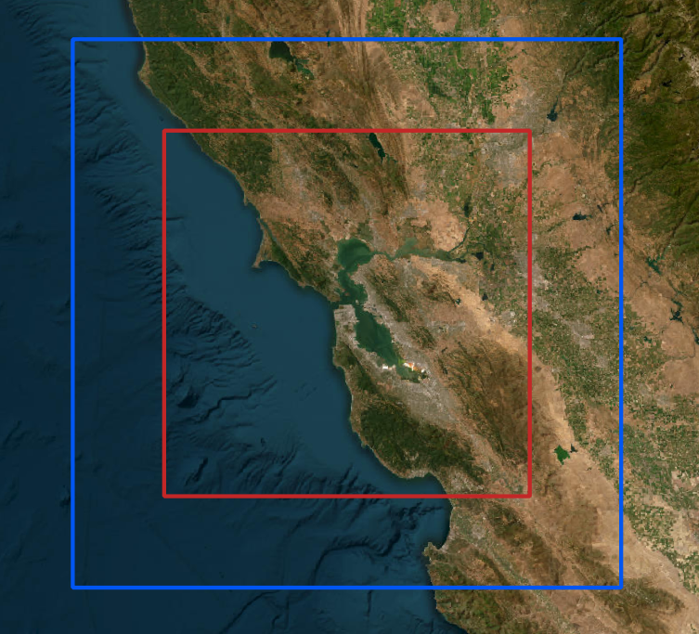

Figure. Red box: Model A Input/Output domain: 200x200 km². Blue box: Model I Input domain: 300x300 km².

Table P1-T1. Dataset fit for this task
Name | Source / exact product | Spatial resolution | Timing | Usable coverage | Fit and limitation
GOES B2 | GOES-17/18 ABI Band 2, 0.64 µm. | 500 m | Every 5 minutes. | Useful for reflected-light cloud detection during daylight. | Observation, not a ready-made cloud mask. Provides fine daytime cloud structure, but requires a classifier.
GOES CSM | GOES-17/18 ABI Level-2 Clear Sky Mask | 2 km | Every 5 minutes | Available day and night. | Provides round-the-clock cloud masks, however at a coarse resolution.
NASA VIIRS | NASA VIIRS Cloud Mask, Collection 002 (daytime) | 375 m | Available only during daytime overpasses | Typically around once daily per satellite (Suomi-NPP and NOAA-20). | High-resolution cloud mask, but coverage is intermittent.

3. Tell the shoreline debugging story
I started by training a simple 2D U-Net-style convolutional neural network to classify GOES B2 pixels as , using raw GOES B2 observations and solar incidence factor as inputs, and NASA's VIIRS daytime clear-sky mask (375 m resolution) as the training target.
After training an initial version on the limited available VIIRS data, I noticed that the model frequently classified coastlines as cloudy, even on days that appeared clearly cloud-free in the raw satellite imagery. Initially, I assumed the model had failed to learn these features correctly. However, upon inspecting the training targets, I discovered that the VIIRS cloud mask itself appeared to be the source of the problem.
The figure below illustrates this issue on June 14, 2026, at 2:00 PM PDT. Both the VIIRS cloud mask and the neural classifier identifies shorelines along San Pablo Bay as cloudy, despite the raw GOES B2 imagery indicating clear conditions. Interestingly, the GOES Cloud and Snow Mask (CSM) does not exhibit the same behavior and appears to classify shorelines more accurately. However, its much coarser spatial resolution (approximately 2 km, compared with VIIRS's 375 m) makes it less suitable as a training target for a model intended to produce predictions at the native 500 m GOES B2 resolution.

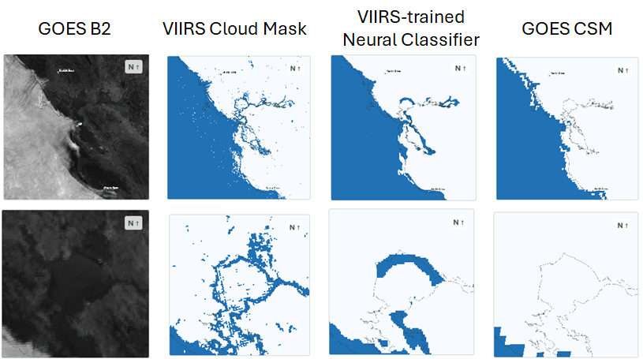

Figure P1-F1. Artifacts in neural classifier outputs inherited from VIIRS training targets. From left to right: raw GOES B2 satellite imagery, NASA VIIRS Cloud Mask, VIIRS-trained neural classifier predictions, and GOES Cloud and Snow Mask (CSM) for reference. The top row shows the full domain, while the bottom row provides a close-up of the San Pablo Bay shoreline to highlight the artifacts. Data from June 14, 2026, at 2:00 PM.

4. Explain the change in approach
So as we just saw, the VIIRS-based neural classifier issues with shorelines. Also, as can be seen in Figure P1-T2, NASA VIIRS doesn’t provide many training targets compared to the GOES B2 and GOES CSM products, and its targets are concentrated in a narrow time band, in the early afternoon. Usable GOES CSM scenes are available year-round and at all hours of the day, while usable GOES B2 scenes, while also available year-round, are limited to daytime only.

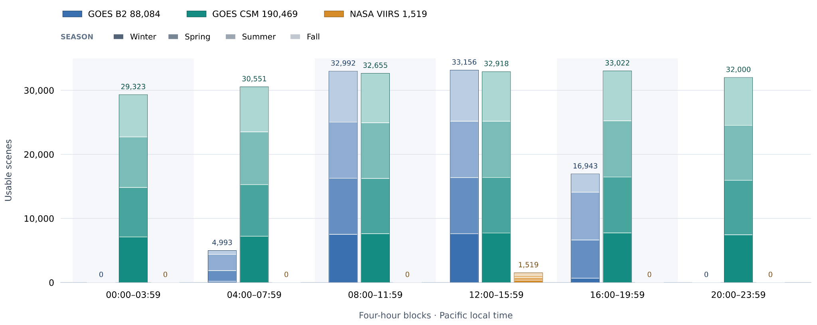
Figure P1-T2. Usable scene counts for GOES B2, GOES CSM, and NASA VIIRS by four-hour interval (Pacific local time), with bars stacked by season.

Therefore, another approach was sought to generate high-resolution cloud mask training targets.
Comparing GOES CSM with associated GOES satellite data under various scenarios, it appears to be free of obvious classification issues. However, its 2 km grid resolution makes it unsuitable as a training target given the sub-kilometer grid resolution objective for the project. Therefore, I decided to use GOES CSM to train a custom-made classifier that turns GOES B2 images (native resolution 500 m) into a B2-derived clear-sky mask at the 500 m grid resolution. In a nutshell, this classifier first creates clear reference B2 fields, using GOES CSM to identify GOES B2 pixels that are free of clouds. Then, a learned fit takes the residual of the actual B2 imagery and the clear reference, in order to classify pixels as cloudy or clear.
However, because GOES B2 is measuring solar reflectance, it can only be used for classification during daytime. Because the objective is to have a 24/7 tool, I decided to use GOES CSM as nighttime supervision, however with a much lower loss weighting due to its coarse spatial resolution.

The changed problem
In the end, it wasn’t enough to pull publicly available high-resolution clear sky masks. Both because of availability and precision, it turned out advantageous to create my own cloud classifier, using raw B2 imagery as the input. This was achieved through a two-step method: first generate sun- and season-aware clear B2 reference fields, then train a learned fitting approach to classify pixels as either clear or cloudy.
POST 2

Part 1. Modeling what the satellite should see without clouds

Estimate clear-sky brightness before identifying clouds

A raw B2 image mixes clouds with the appearance of the surface under changing illumination. I modeled the clear-sky appearance first. As illustrated in Figure P2-F1, Subtracting that reference produces a residual that should stay near zero for clear pixels and typically becomes positive when clouds increase the observed reflectance. We feed this residual map into a fitted sigmoid to output a continuous cloud score, which is then thresholded to obtain the binary daytime cloud mask, both a fine-scale input and target for the forecast neural network.

It is a simple and intuitive approach whose main benefits are generation of an abundance of training targets, and interpretability. This decomposition gives me concrete fields to inspect: the clear reference, the residual, and the continuous cloud score. An alternative approach would have been to keep the VIIRS-based neural approach, but this suffered from a scarcity of VIIRS targets, classification issues, and less interpretability.

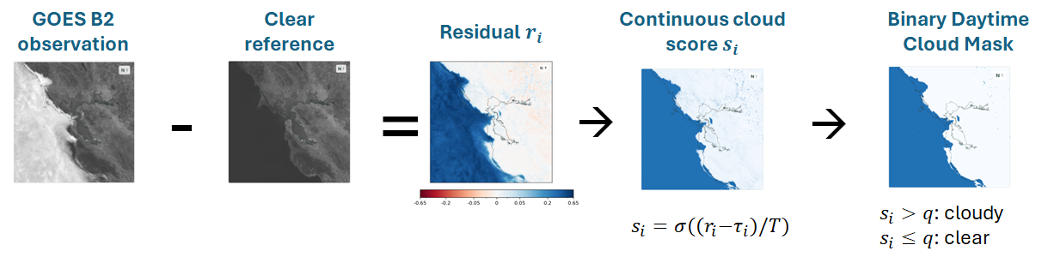
Figure P2-F1. Classifier pipeline, from observation to daytime mask. The residual between the observed B2 and the clear reference is passed through a fitted sigmoid to generate a continuous score, and a cutoff produces a binary daytime mask.

Fit a physically motivated model at each pixel
First, we need to come up with a B2 clear reference.
For each grid cell, the clear-sky reference uses an 11-term basis $φ$ plus an offset for GOES-18, since the reference was fitted using both GOES-17 and GOES-18 satellite imagery. The offset allows potential systematic differences in reflectance between the two satellites, for instance due to slightly different sensors or calibration, to be taken into account.
The cosine of solar zenith angle c = cos(SZA) describes incident illumination on a horizontal surface. A solar-hour term p lets the model make the difference between morning and afternoon, as illustrated in Figure P2-F2. Annual sine and cosine terms allow seasonal variation and interactions with illumination.

$$R_{clear} = β_{x,y} · φ(c,p,d) + b_{18,x,y} I(GOES 18)$$
$$φ = [1, c, c^{2}, p, cp, sin(d), cos(d), c sin(d), c cos(d), p sin(d), p cos(d)]$$
$$c = cos(SZA) p = sin(π(h_{solar} - 12)/12)$$
$$d = 2π(D_{UTC} - 1)/N_{days}$$
Here h_{solar} is solar hour computed from UTC using longitude and an equation-of-time correction, D_{UTC} is fractional UTC day of year, d is annual phase, and the coefficients vary by grid cell.
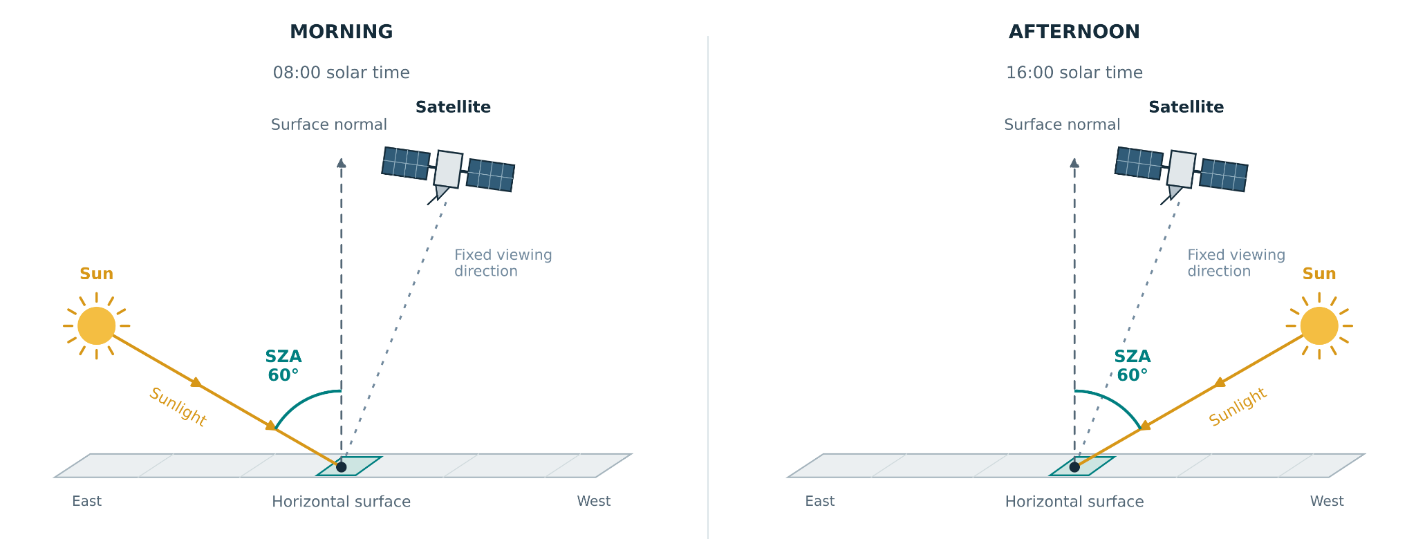
Figure P2-F2. Morning (left) and afternoon (right) have the same solar zenith angle (SZA) but different solar directions. The solar-hour term (p) allows the fit to capture potential differences in satellite-measured reflectance between them.
GOES CSM identified clear observations for fitting the B2 clear-sky reference. Pixels were accepted only if their surrounding 3 × 3 CSM pixel neighborhood was clear and SZA ≤ 82°. The fit processed more than 85,000 candidate scenes from 2019 to 2026, with more than 4 billion accepted clear-sky pixel observations.
A cell retained its own fitted coefficients only if it had accepted clear observations on at least 12 distinct UTC dates. Cells with insufficient support borrowed coefficients from nearby well-supported cells with similar land/water composition.

Table P2-T1. Held-out mean absolute error (MAE) and root mean square error (RMSE) of clear-sky GOES Band 2 reflectance predictions for nested 3-, 5-, 7-, 9-, and 11-term clear-sky reference models. Models share coefficients across GOES-17 and GOES-18, with a cell-specific GOES-18 offset. Errors are in reflectance units; lower values indicate better agreement with accepted clear-sky observations.
Basis | Terms added at this stage | Held-out MAE |  | Held-out RMSE
 |  | GOES-17 | GOES-18 | GOES-17 | GOES-18
3 terms | Constant, c, c² | 0.011737 | 0.010682 | 0.018420 | 0.015869
5 terms | Morning–afternoon p and cp | 0.010298 | 0.009064 | 0.017056 | 0.013982
7 terms | Annual sine and cosine | 0.008781 | 0.006439 | 0.014815 | 0.010056
9 terms | Illumination × annual phase | 0.007974 | 0.005495 | 0.013929 | 0.008876
11 terms | Morning–afternoon × annual phase | 0.007510 | 0.005101 | 0.013666 | 0.008443
11 terms - stabilized | N/A | 0.007526 | 0.005227 | 0.013709 | 0.008511

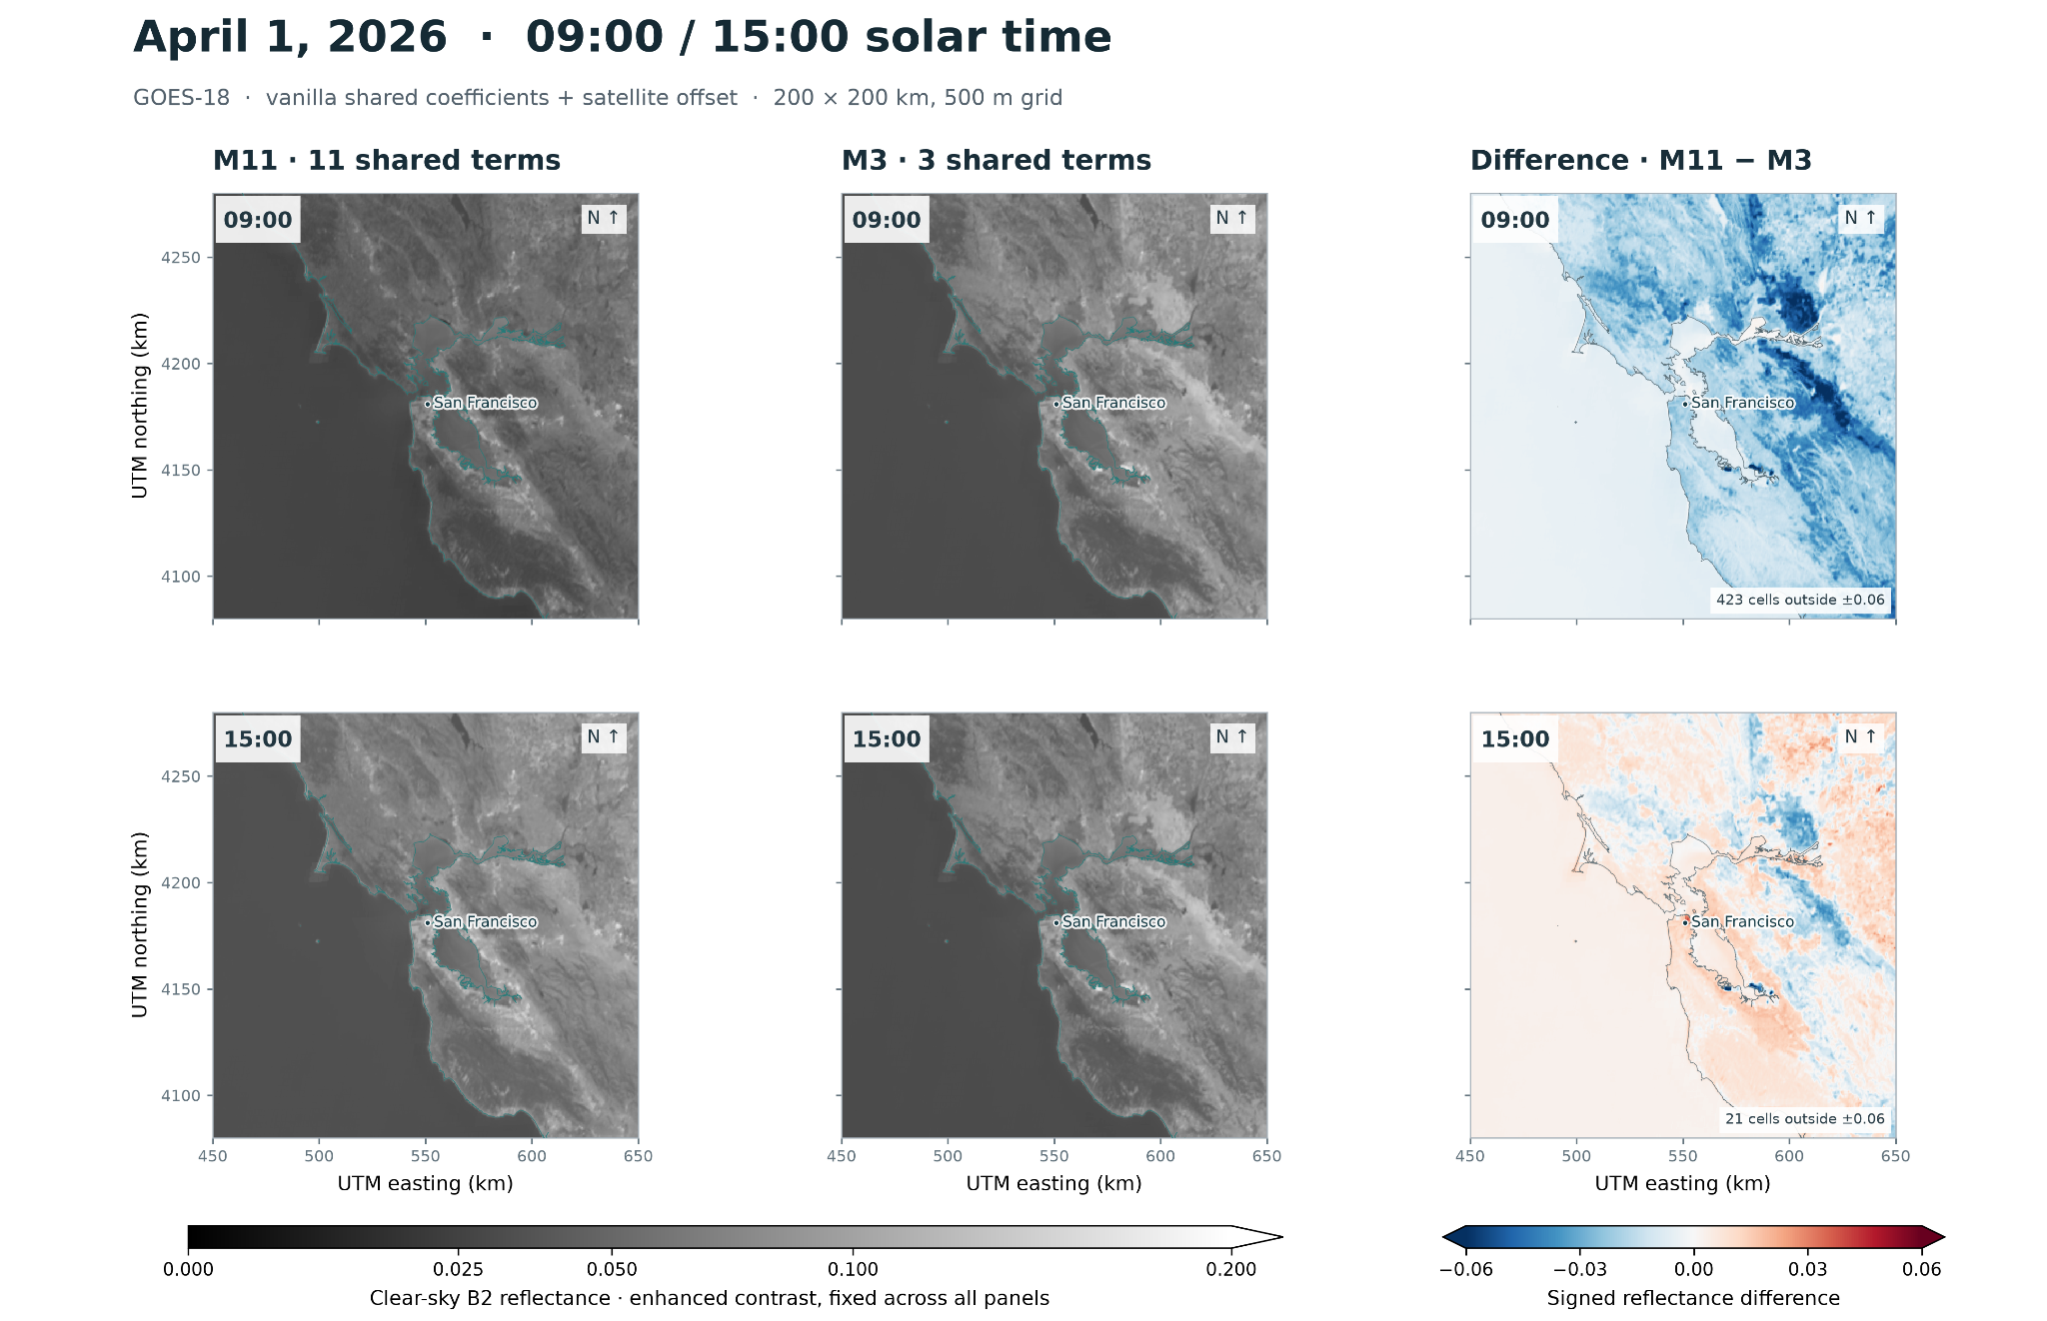
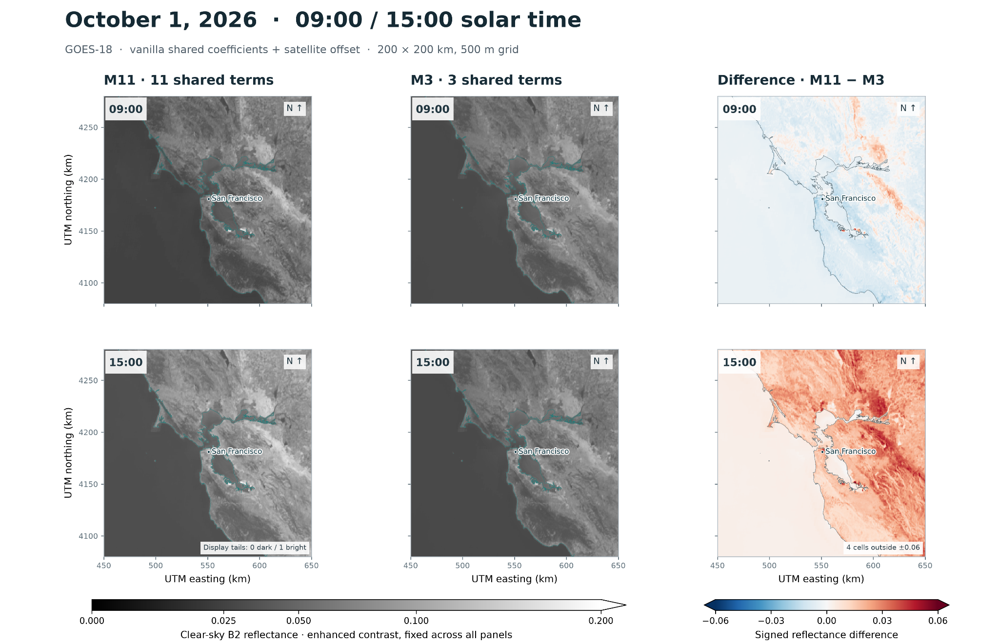

Figure P2-F2. Comparison between the M11 and M3 clear-sky reference fits, at different times of the day and year.

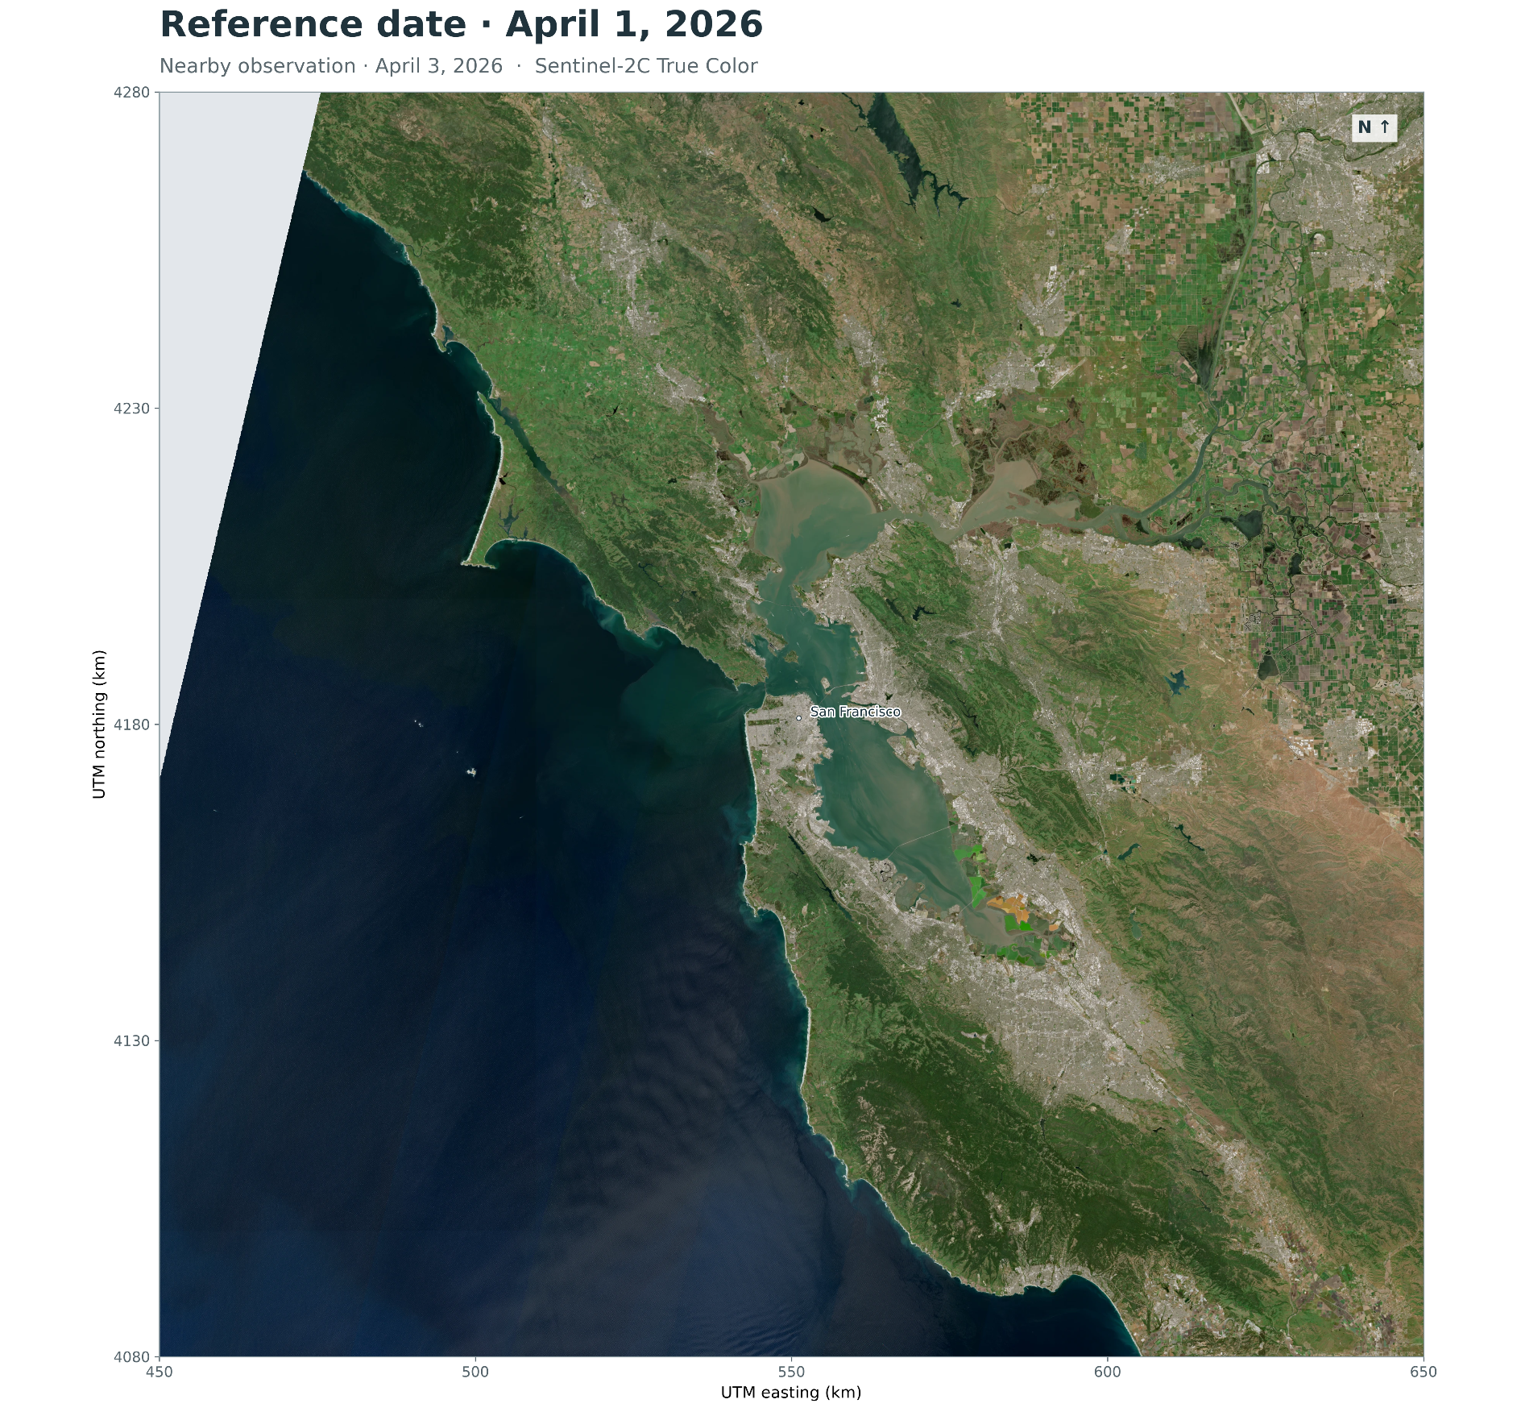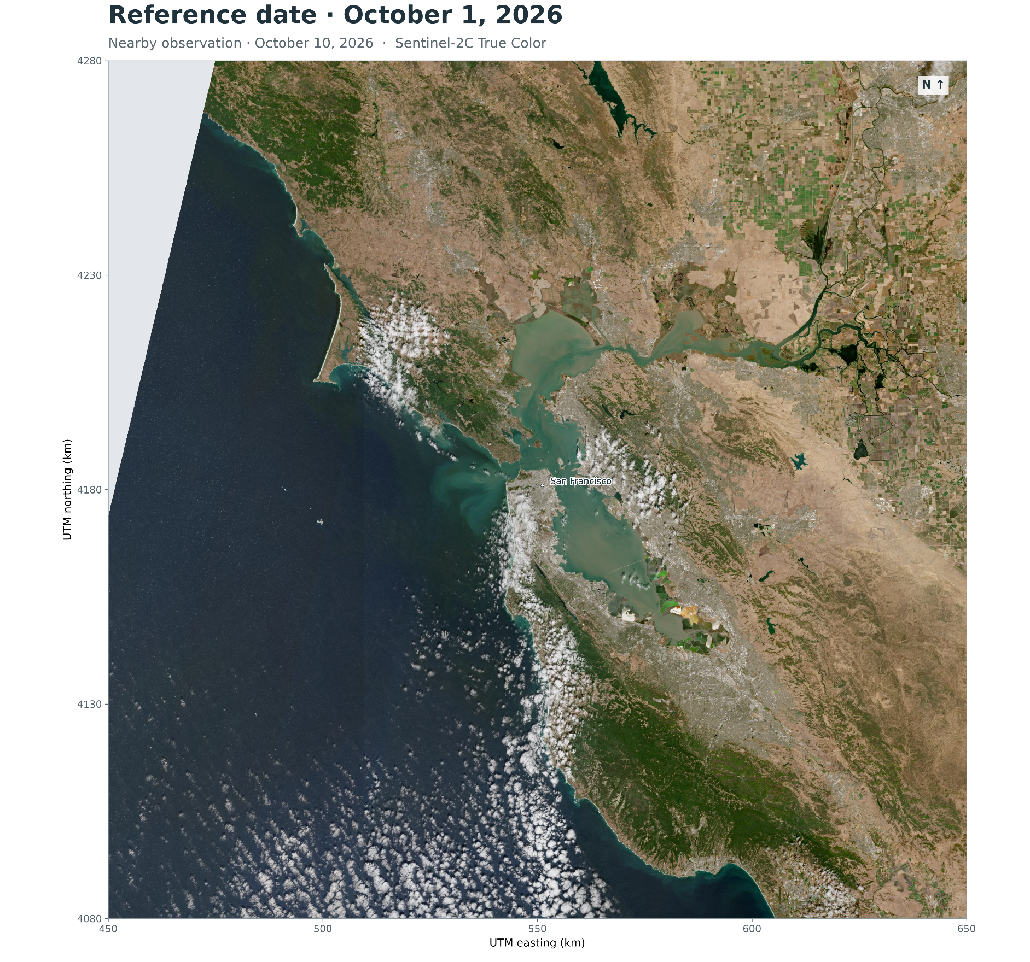
Figure P2-F3. Seasonal differences in surface appearance. True-color Sentinel-2 images of the study domain on April 3 and October 10, 2026, obtained from Copernicus Browser. Changes in vegetation and surface appearance provide qualitative motivation for including a seasonal component in the GOES B2 clear-sky reference, although these images alone do not establish its quantitative benefit.

Does stabilization reduce held-out errors?

The decision we made of having each pixel come up with its own 11-term fit can potentially raise the issue that some of the pixels will come up with poor fits due to poor and/or limited data. Specifically, we were worried that an 11-term fit would overfit to the training data. To this end, we explored whether stabilization would help. We introduced ridge regularization to stabilize the coefficients except the two intercept terms, and one Huber reweighting pass with δ = 0.03 tp reduce the influence of large residuals (outliers). Also, to keep the fit from being dominated by dense days, within each grid cell, a day with many accepted observations receives the same total weight as a day with one.

As can be seen in Table P2-T1, the performance of the 11 terms model with stabilization is slightly worst than its “vanilla” counterpart.

Part 2. Turn a brightness residual into a cloud score

Fit the separation after removing clear brightness
With the sun-aware and season-aware clear-sky reference in place, the next step was to determine from this residual whether a pixel is clear or cloudy. To this end, I fitted a simple threshold $τ_{i}$ to the residual. The threshold has a global quadratic dependence on solar incidence and a local pixel offset $Δ_{x,y}$. Shrinking the local offsets toward zero lets local corrections depart from the global rule when the fitting data support them.

$$r_{i} = {B2}_{i} - R_{clear,i}$$
$$τ_{i} =τ_{global}+ Δ_{x,y}$$
$$τ_{global}= a_{0} + a_{1}c_{i} + a_{2}c_{i}^{2}$$
$$s_{i} = σ((r_{i} - τ_{i})/T)$$
The score s increases toward cloudy conditions, and T is a fitted temperature. I kept the functional form of $τ_{i}$, assuming that the hard part of the work has already been done by coming up with the clear-sky reference. The loss function for the threshold fit is given by:
$$L = \sum_{i}{}w_{i} BCE(y_{i}, s_{i}) + (λ/P) \sum_{j}{}Δ_{j}^{2}$$
Where w_{i} is the weight such that for each pixel and UTC data, the sum of the weights for that day sums to one (the goal is to prevent days with a lot of observations to dominate), BCE(y_{i}, s_{i}) is the binary cross-entropy between the cloud score and the CSM target y_{i}, $λ$ is the regularization parameter, The first term measures weighted disagreement with the labels, and the second term shrinks the local pixel offsets d towards zero (regularization); with P the number of local offsets.
Again, GOES CSM provides the training targets. Because of the mismatch in spatial resolution between GOES B2 and CSM, the cloud-score fit required a homogeneous 3×3 neighborhood on the native GOES CSM grid. In other words, the center and all eight surrounding pixels had to pass quality checks and agree on the clear/cloudy class.
The results below show that the residual cloud mask performs consistently like GOES CSM, but at a higher resolution, similar to VIIRS but much better than VIIRS.
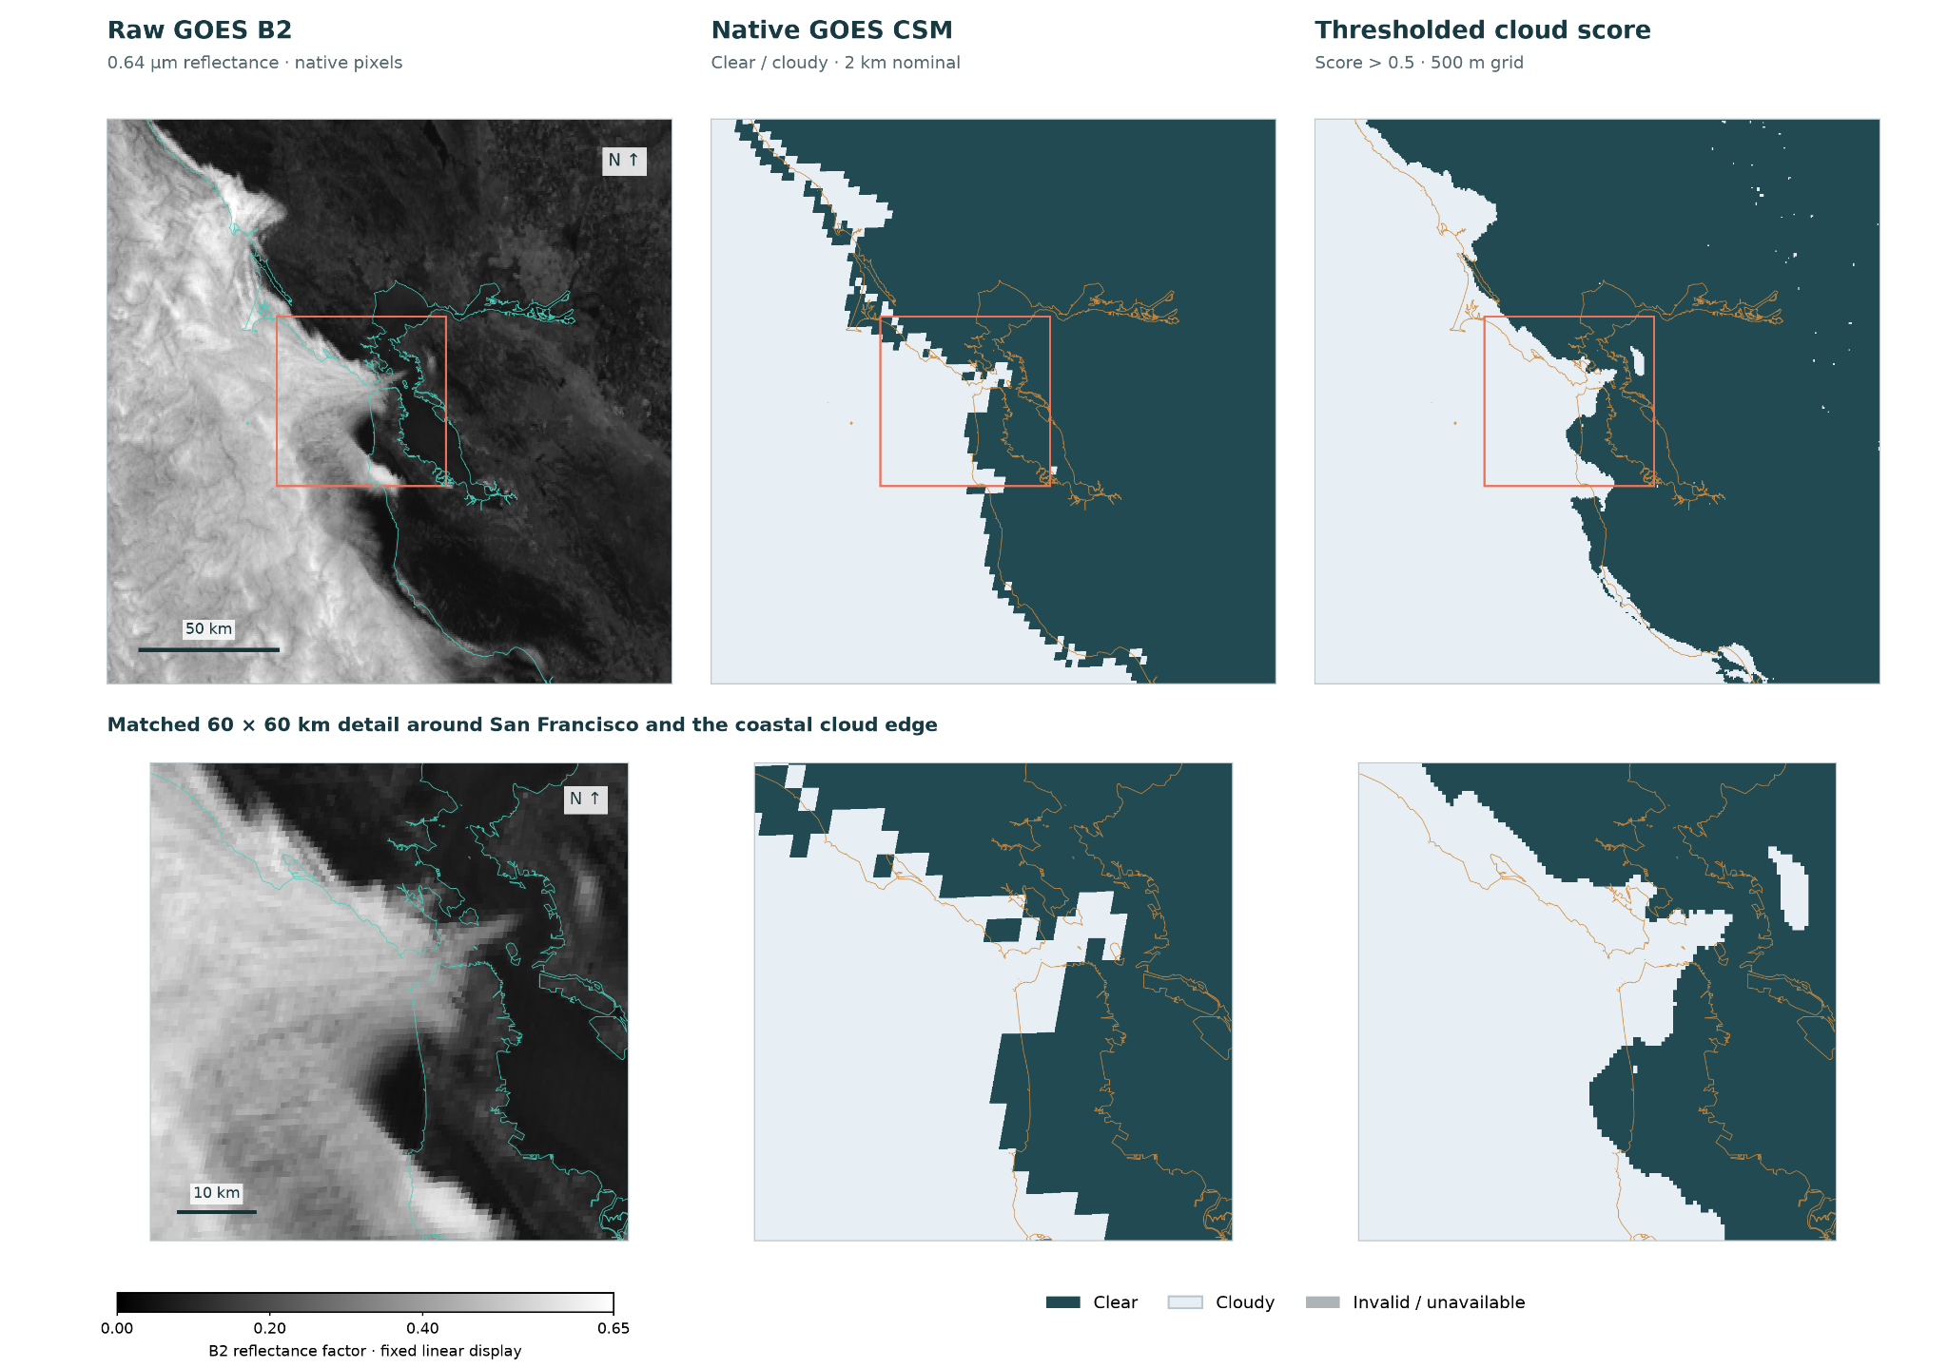
Figure P2-F4. Representative scene showing a retreating coastal cloud bank, June 14, 2026 at 12:30PM PDT. Left: raw GOES-18 B2 reflectance. Center: native GOES CSM. Right: thresholded cloud score on the native GOES B2 grid.

POST 3

What should a neural network learn when a weather forecast already exists?

The forecasting contract
The baseline model uses a 200 × 200 km domain with ten hourly outputs at +1 through +10 hours, and a 500 m grid resolution. Additional inputs enter the model on a 100 × 100 coarse grid with 2 km grid resolution. The output logits are fed into a logistic sigmoid to obtain how likely a given location and time to be cloud-free, i.e., clear-sky, with 1 representing most likely to be clear, and 0 most likely to be cloudy.

The inputs for the base Model (Model A) are listed and described in Table P3-T1 and illustrated in Figure P3-F1. Essentially,

Table P3-T1.
Input group | Fields provided | Channels | Information contributed
Fine current observation | B2-derived clear score and its validity mask | 2 | Current fine-scale daytime cloud/clear structure; the mask identifies usable observations
Fine geography | Land fraction and elevation | 2 | Land-water boundaries and terrain height, providing context for coastal and elevation-dependent cloud patterns
Fine solar context | Solar incidence at issuance | 1 | Current solar geometry and daylight conditions, providing context for interpreting satellite observations
Coarse external forecasts | NBM total cloud cover at issuance and +1…+10 h | 11 | Large-scale numerical weather prediction on cloud-cover distribution and its expected evolution over the forecast window
Coarse solar context | Solar incidence at +1…+10 h | 10 | Solar geometry and daylight conditions at each forecast horizon.
Coarse current observation | CSM and its validity mask | 2 | Current coarse-scale cloud/clear structure, including nighttime; the mask identifies usable observations
Coarse seasonal context | Annual sine and cosine at issuance | 2 | Seasonal changes in reflectance, such as shifts in grassland color

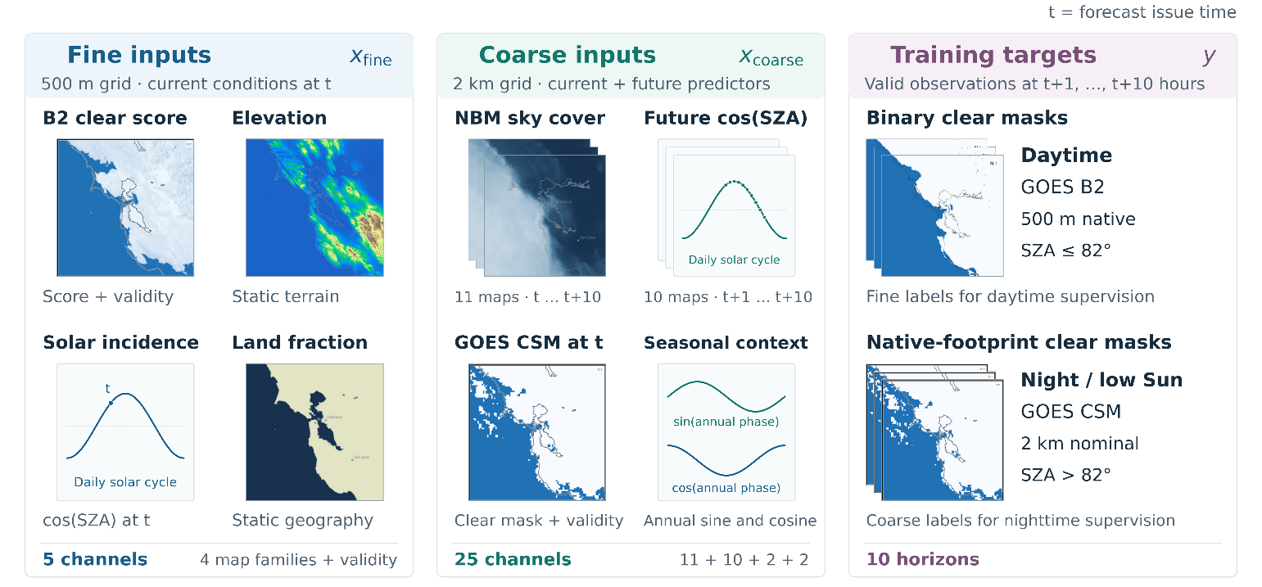
Figure P3-F1. Model inputs and targets.

Motivation for the architecture
I chose a residual U-Net because cloud patterns have structure at multiple spatial scales. The encoder gathers broader context as it reduces spatial resolution; the decoder reconstructs a detailed forecast. U-Net skip connections pass fine spatial detail from the encoder to the decoder. Shortcuts inside residual blocks serve a different role: they make it easier to learn a small change to an existing feature representation.
The architecture combines the fine observations with coarse forecast context. The model has an inductive bias, that local prediction everywhere in the domain are the same function of theirs and their neighborhood observations.
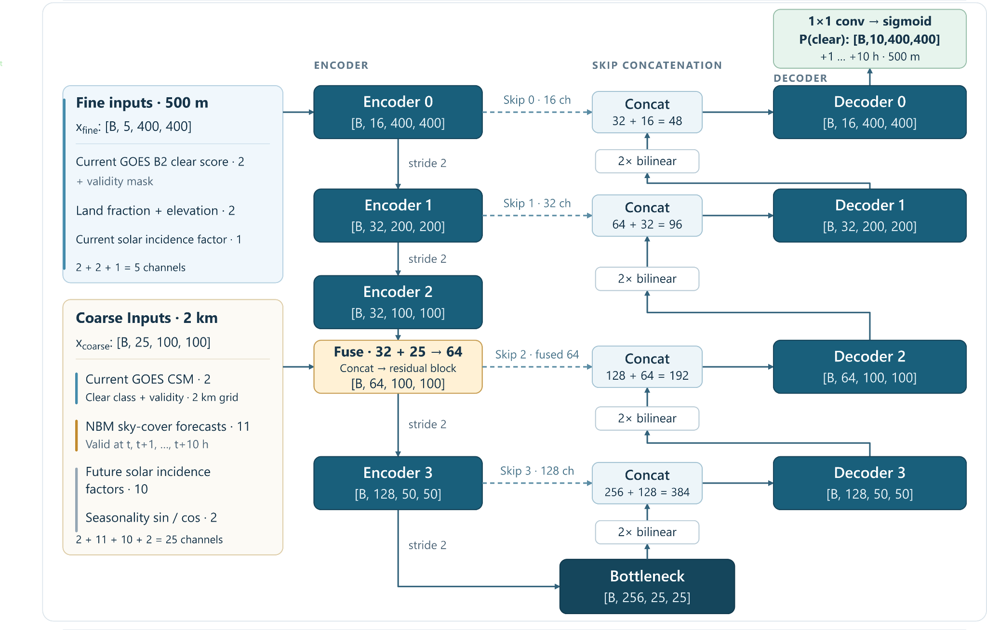
P3-F2. Residual U-net schematic. Fine and coarse inputs enter the networks at different encoder scales. Four skip connections preserve spatial detail. At the bottleneck, the spatial resolution is 16 times coarser than the fine inputs. Each block is a residual block with a shortcut path to facilitate training. Ten output fields contain the logits that are used to compute the predicted clear-sky probabilities.

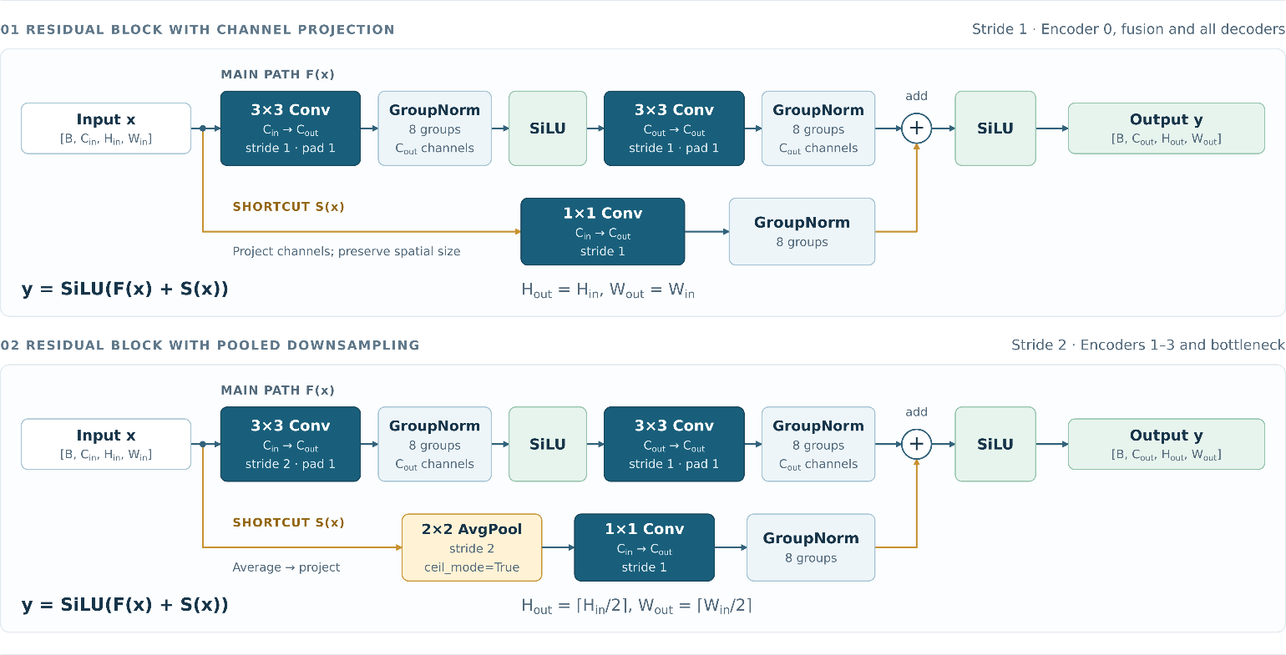
P3-F3. Residual blocks in the Fogcast U-Net. Top: Stride 1: encoder 0, fusion and all decoders. The channel-projection block preserves spatial resolution and matches channel counts through a 1×1 shortcut convolution. Bottom: Stride 2: encoder 1-3 and bottleneck. The pooled-downsampling block (bottom) uses a stride-2 3×3 convolution in the main path and 2×2 average pooling followed by a stride-1 1×1 convolution in the shortcut. Both main paths contain two 3×3 convolutions with eight-group normalization and an intermediate SiLU activation. Branch outputs are added elementwise before a final SiLU activation. Subscripts “in” and “out” denote input and output tensor dimensions.

The loss function
The loss function used is binary cross-entropy, with both coarse-scale and fine-scale entropy:
$$F_{t}=\frac{1}{N_{P,F}}\sum_{i}{\left(-y_{i,t}^{F}\log{(p_{i,t}^{F}}\right)-\left(1-y_{i,t}^{F}\right)\log{(1-p_{i,t}^{F})}}$$
$$C_{t}=\frac{1}{N_{P,C}}\sum_{i}{\left(-y_{i,t}^{C}\log{(p_{i,t}^{C}}\right)-\left(1-y_{i,t}^{C}\right)\log{(1-p_{i,t}^{C})}}$$
$$L=\frac{1}{N_{t}}\sum_{t=1}^{10}{F_{t}+αC_{t}}$$

Figure P3-F4 shows how binary cross-entropy is computed for nighttime supervision when predictions and labels use different grids. Predicted clear-sky probabilities on the 500 m grid are averaged over each native GOES CSM footprint using overlap-area weights, then compared with its binary clear/cloudy label. The overlap mapping is precomputed once per grid geometry and reused throughout training; gradients pass through the pooling operation to the fine-grid predictions.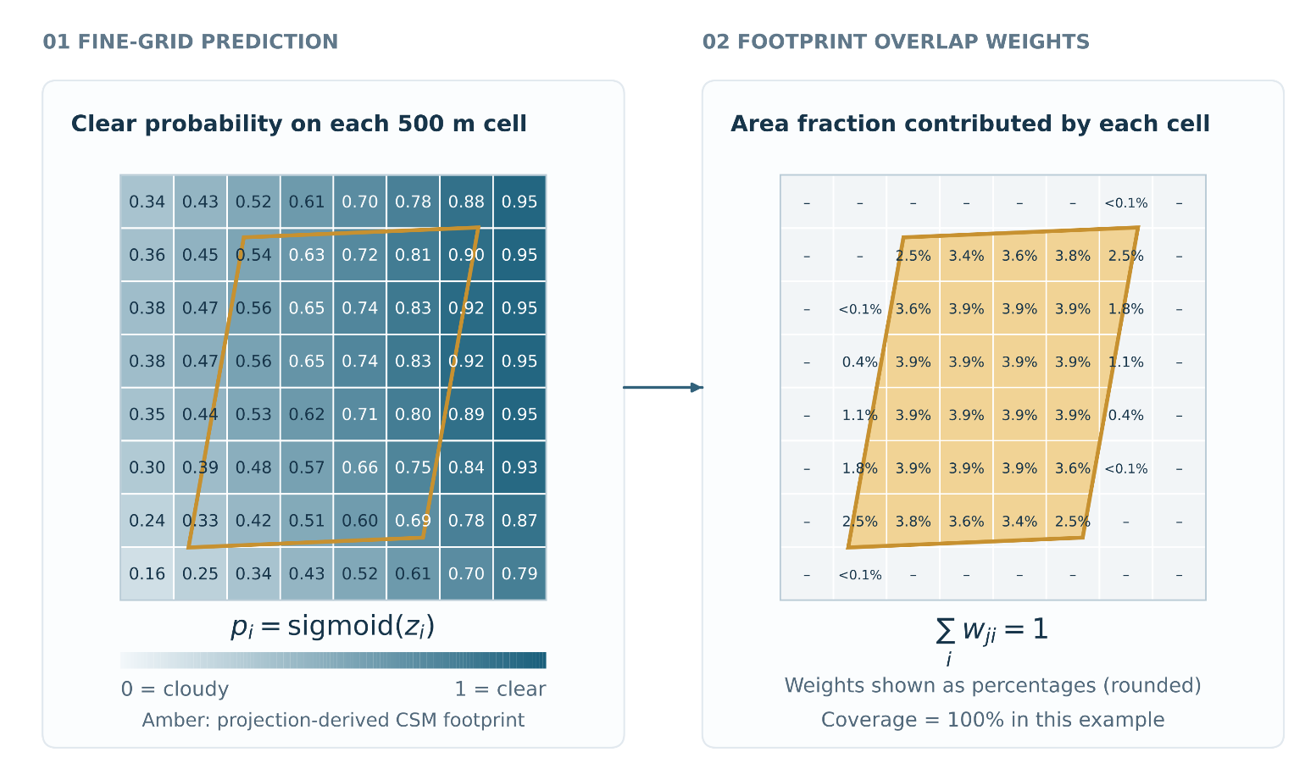
Figure P3-F4. Comparing fine-grid forecasts with native satellite labels. During nighttime, clear-sky probabilities at 500 m are pooled over native GOES CSM footprints using precomputed overlap-area weights, then compared with binary satellite labels using binary cross-entropy. The mapping is reused throughout training; probabilities shown are illustrative.

The information-availability boundary
Obviously, for the model training to be relevant, the forecast must be issued using only information available at that time, i.e.., the forecast issue time must be later than the time at which all the input data has been made available. The GOES observations (B2 and CSM) are taken to be the latest made available at the time of issuing the forecast. The GOES scan lasts about 160 seconds, such that it is useful to consider the scan midpoint vs the scan end time, which are about 80 seconds apart.

Table P3-T2. Timestamp selection rules for input data and target labels.
Data | Timestamp-selection rule | Example: forecast issued at 1:00 PM
Current GOES CSM and processed B2 satellite images | Select the latest scan that completed by t and whose midpoint is between t-20 minutes and t | Scan midpoint between 12:40 and 1:00 PM, with scan end no later than 1:00 PM
NBM forecasts | Use the cycle that was initialized at t=t-2hours; use all 11 maps at t+h, with h=0,…,10 hours from that cycle. | Use the 11:00 AM cycle, and 11 hourly forecasts leads at 1:00PM, 2:00PM, …, 11:00PM.
Training targets: future B2/CSM observations | Select the nearest observation with scan midpoint within +/- 6 minutes of t+h, for horizons h=1,..10 hours | The +1 hour target will have scan midpoint between 1:54PM and 2:06PM.

POST 4

Which inputs actually help?
Central question: Which plausible additions survive a controlled experiment?

1. Ten different model variations
Table P4-T1 shows the ten different models that were trained. Model A is the reference model, and the nine other models are various ablations meant to answer targeted questions, and each is defined in relation to Model A.

Table P4-T1. Input and architecture ablations for the fog forecast model. Each variant modifies reference model A as described. TEST-set Brier scores use unthresholded probabilities and are averaged equally across forecast lead times of 1–10 hours; lower values indicate better performance. Daytime scores use valid fine-resolution B2-derived labels, while nighttime/low-Sun scores use native CSM labels. The paired difference cells are colored according to whether they show improvements over Model A: yellow is inconclusive, green is improved, and red is worse performance.
Model label | Change from A | Expected change/benefit | Average daytime Brier score | Average nighttime Brier score | Paired daytime difference from A [95% CI] | Paired nighttime difference from A [95% CI]
A | Reference model | N/A | 0.0913 | 0.1088 | +0.0000 | +0.0000
B | Remove both satellite inputs and masks | Test the contribution of satellite observations; expect weaker knowledge of the initial cloud stat | 0.1018 | 0.1249 | +0.0105 [0.0081, 0.0131] | +0.0162 [0.0140, 0.0183]
C | Add previous-hour satellite inputs / masks | Provide recent cloud evolution to help infer movement, growth and dissipation | 0.0924 | 0.1092 | +0.0028 [0.0022, 0.0034] | +0.0004 [-0.0001, 0.0009]
D | Remove B2-derived score and its mask | Isolate the contribution of fine-resolution daytime observations while retaining CSM cloud information | 0.0941 | 0.1092 | +0.0011 [0.0006, 0.0016] | +0.0005 [0.0001, 0.0009]
E | Add NBM ensemble sky-cover spread and a shared validity mask | Provide ensemble disagreement as an uncertainty cue for adjusting reliance on NBM guidance | 0.0909 | 0.1084 | -0.0004 [-0.0016, 0.0004] | -0.0003 [-0.0010, 0.0003]
F | Add low-cloud (below 3,000 ft) probability maps and masks | Provide targeted low-cloud cover predictions that cannot be recovered from total cloud cover alone | 0.0904 | 0.1092 | -0.0009 [-0.0022, 0.0001] | +0.0004 [-0.0002, 0.0011]
G | Add four-head bottleneck spatial attention | Enable interactions between distant cloud features and improve spatial coherence | 0.0929 | 0.1114 | +0.0015 [0.0005, 0.0026] | +0.0026 [0.0020, 0.0033]
I | Expand input to 300 × 300 km | Capture approaching cloud systems and provide additional context near output boundaries; expect better predictions especially close to the domain edges | 0.0913 | 0.1068 | +0.0000 [-0.0010, 0.0010] | -0.0020 [-0.0028, -0.0012]
J | Remove direct land-fraction and elevation inputs | Test the contribution of explicit coastal and terrain information to local cloud patterns; expect weaker predictions | 0.0939 | 0.1117 | +0.0026 [0.0018, 0.0034] | +0.0029 [0.0023, 0.0036]
K | Remove all eleven NBM total-cloud-cover maps | Test the contribution of numerical forecast guidance; expect weaker prediction especially at longer lead times | 0.1240 | 0.1333 | +0.0327 [0.0275, 0.0374] | +0.0245 [0.0208, 0.0281]

2. Are the satellite inputs useful?
Model B was designed to assess forecast performance without either coarse- or fine-scale satellite inputs. It uses the NBM forecast alongside ancillary inputs such as solar incidence angle, land fraction, and elevation. As shown in Figure P4-F1, Model B slightly outperforms the NBM forecast itself (Direct NBM) during both daytime and nighttime. However, it performs substantially worse than Model A, which includes both satellite inputs, and Model D, which includes only the coarse satellite input. These differences are especially pronounced at short forecast horizons.
Model D differs from Model A only in its omission of the fine-scale satellite-derived input. This omission reduces daytime performance but has little effect on nighttime performance. This pattern is consistent with the training targets: the fine-scale B2-derived score during daytime and coarse CSM observations at night. The results therefore suggest that the fine-scale input is particularly valuable for daytime forecasts, when predictions are evaluated against a target derived from the same satellite product.
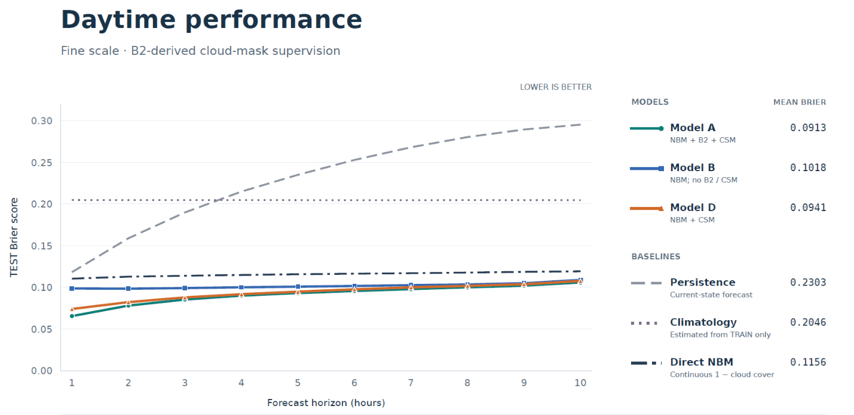
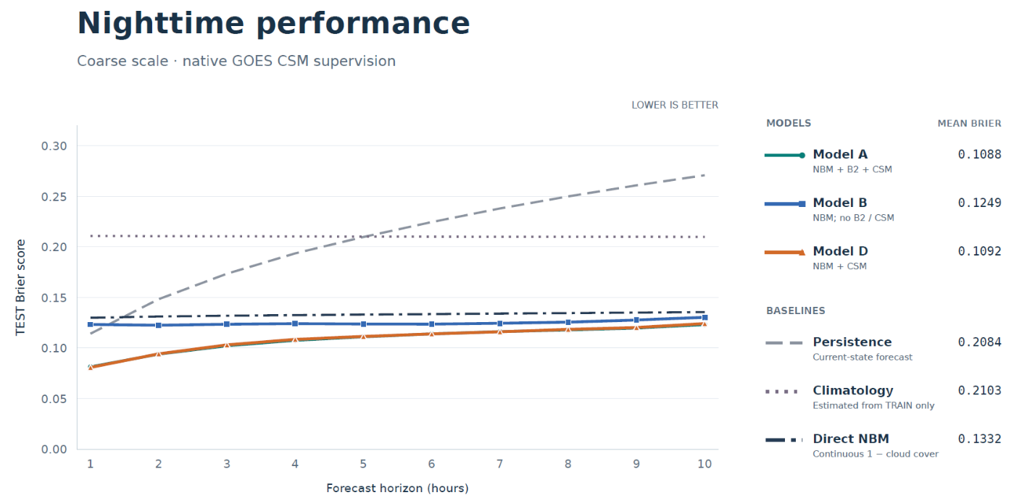
Figure P4-F1. Daytime and nighttime forecast performance across lead times for reference Model A, Model B with both current satellite inputs removed, and Model D with only the fine-scale satellite input removed. Three additional benchmarks are shown for comparison. Removing both satellite inputs degrades performance most strongly at short lead times, with the gap narrowing at longer lead times. Removing only the fine-scale input modestly degrades short-lead daytime forecasts but has little effect on nighttime performance. Fine-scale satellite observations are available only during daylight.

3. Impact of a larger input domain and spatial attention
The one-sided convolutional reach is about 43 kilometers, meaning that through the learned convolutions, a prediction at a given point is influenced by inputs as far as 43 kilometers in any of the 4 cardinal directions. Two ablations will test whether this convolutional reach is sufficient, and whether associated boundary effects are problematic:
- Model G adds a spatial attention block at the bottleneck, enabling a prediction at a given location to be influenced by any other location. As shown in Figure P4-F2, the addition of a spatial attention block decreased both daytime and nighttime performance. While theoretically, Model G could recover Model A performance by using Model A’s weights and setting the Model G corrections to zero, such performance is not guaranteed, as Model G weights were initialized from scratch. A few possibilities for the degradation:
  - the same training settings (regularization and learning rate recipe) were used for both A and G, and they don’t fit G as well.
  - Extra flexibility can hurt generalization: Figure P4-F2-2 shows the combined BCE loss as a function of training epoch. It can be seen that Model G achieves lower training loss eventually, but that it is accompanied by a higher validation loss. Thus, the 25% additional parameters might be learning relationships that hold in the training dataset, but fail elsewhere.
- Model I adds a “halo” of 50 km in each cardinal direction for the input domain, resulting in a 300x300 km2 domain, while keeping the output domain the same. This should remove most of the boundary effects, if there were any, by exposing more of the surrounding weather patterns. It is therefore a targeted test to determine whether boundary effects are significantly harming performance for the baseline 200x200 km2 input domain. As shown in Figure P4-F3, the reported mean is unchanged to four decimals by day and improves from 0.1088 to 0.1068 at night.

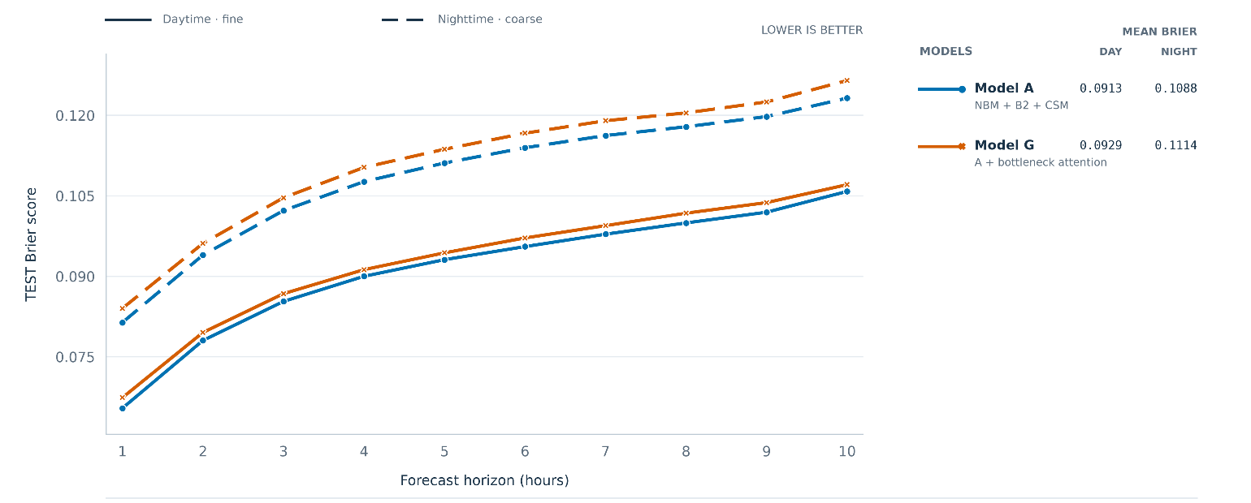
Figure P4-F2. Daytime and nighttime forecast for Model A (reference) and Model G (addition of spatial attention block right after the bottleneck). The dashed and solid lines represent nighttime and daytime forecast performance, respectively.

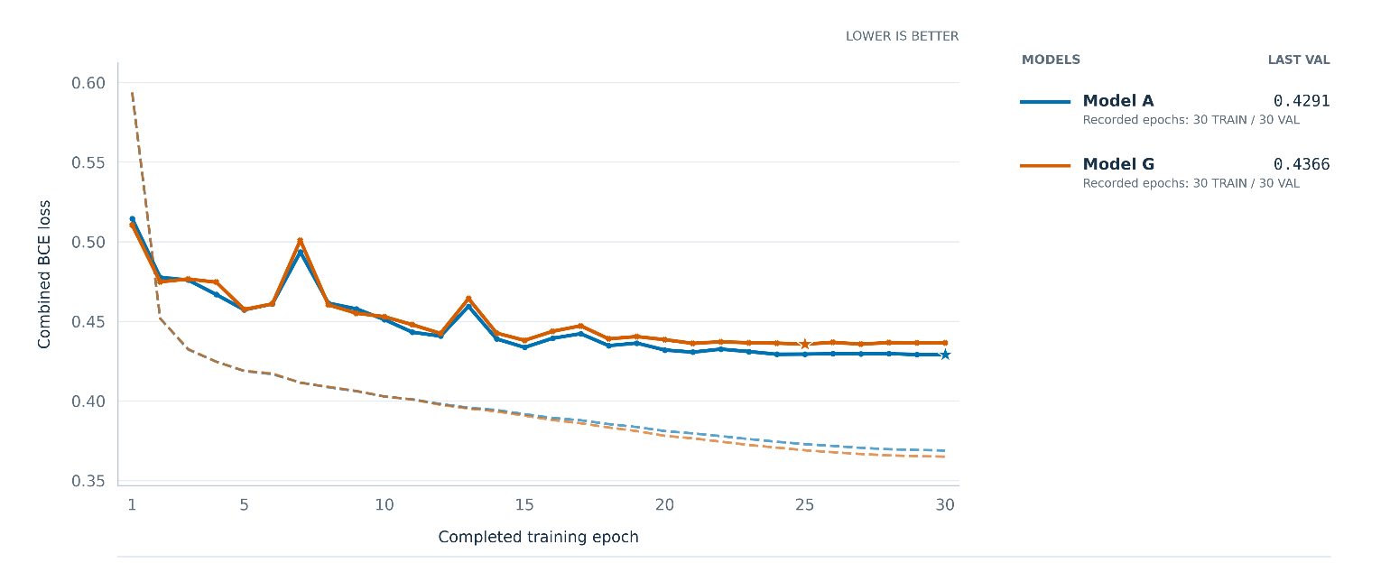
Figure P4-F2-2. Combined BCE learning curves for Models A and G. The solid line shows the validation loss, while the dashed line shows the training loss. The starts show the checkpoints selected by BCE computed on the validation set.

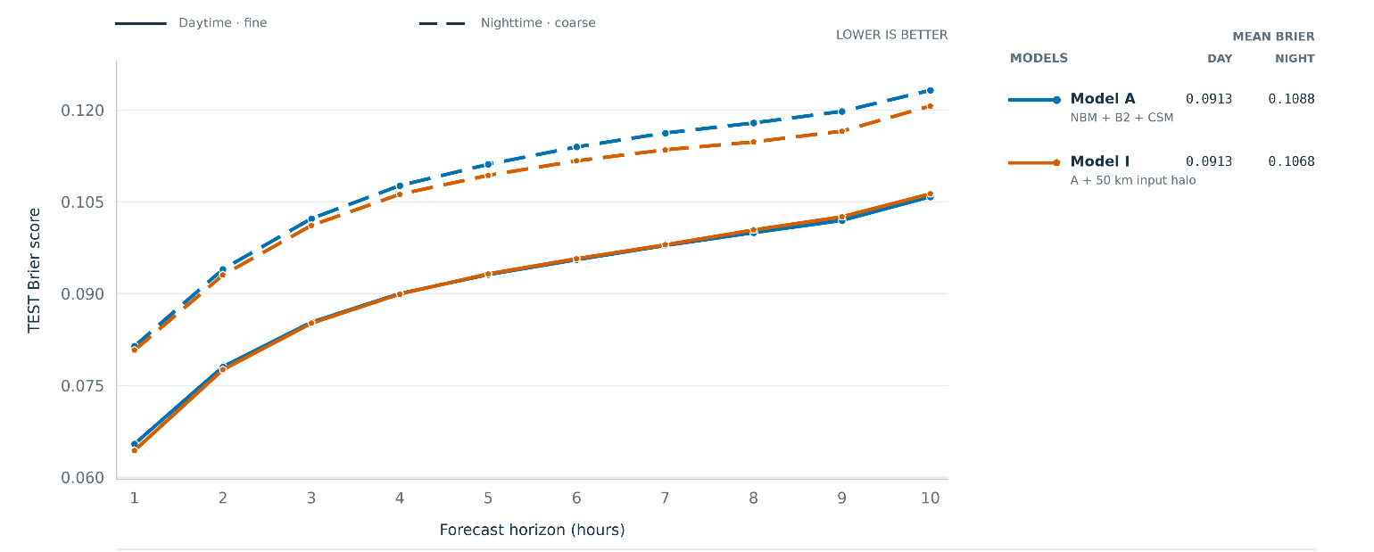
Figure P4-F3. Daytime and nighttime forecast performance for Model A (standard 200x200 km2 input domain) and Model I (larger 300x300 km2 input domain). The dashed and solid lines represent nighttime and daytime forecast performance, respectively.

4. Are the forecast inputs useful?
How well would the reference model perform without the NBM forecasts? This is what motivated the Model K ablation. Model K is the same architecture as Model A, except the NBM forecasts are not included. Model K is trained from scratch using the same regularization and learning rate recipe. It was expected that Model K will perform much worst than Model A, however it wasn’t obvious how that degradation would be as a function of forecast horizon. It was expected that the degradation would be most pronounced at long horizons, where it is expected that the model relies most heavily on the forecast inputs.
Figure P4-F3 shows that, while Model A performs significantly better than the NBM baseline for all horizons day and night, Model K performs better than the baselines for forecast horizons up to about 4 hours, and performs significantly worse for longer horizons. This is a useful ablation to understand the relative importance of the information provided by satellite images and forecast inputs, as a function of the forecast horizon.
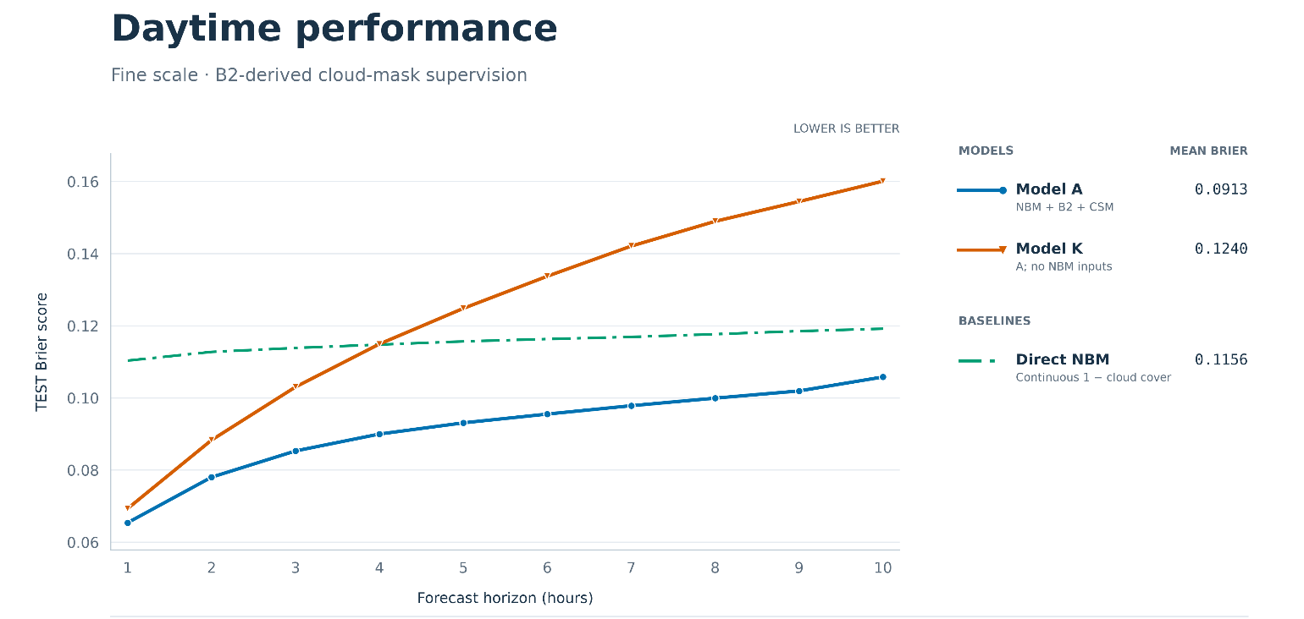
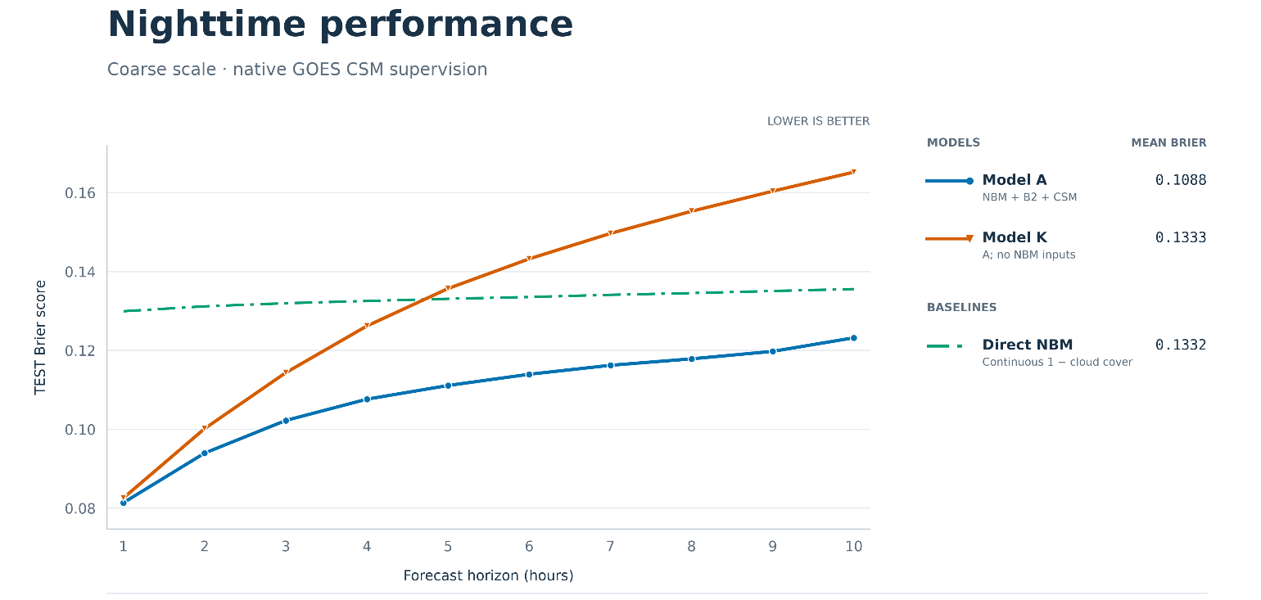
Figure P4-F3. Daytime (top) and nighttime (bottom) performance for Model A (reference, solid blue) vs Model K (Model A without the NBM forecast inputs, plotted in solid red). The NBM baseline is also shown using a green dashed line.

5. Are the static landscape inputs useful?
In the reference Model A, at the fine-scale input level, two static input feature maps are fed, the normalized elevation and land fraction. This addition is based on the assumption that cloudiness at a given location is correlated with its elevation as well as whether it is land or water, as well as changes in these properties in the location’s neighborhood. In other words, it is assumed that these two static input maps provide useful information to the model because different locations with similar land fraction and elevation patterns in their neighborhood, share more similar cloudiness patterns because of that, compared to two given locations that do not share such similar patterns.

Figure P4-F4 shows that indeed this appears to be the case, with Model J performing more poorly than Model A day and night, across all horizons, with deterioration more pronounced at longer forecasting horizons.

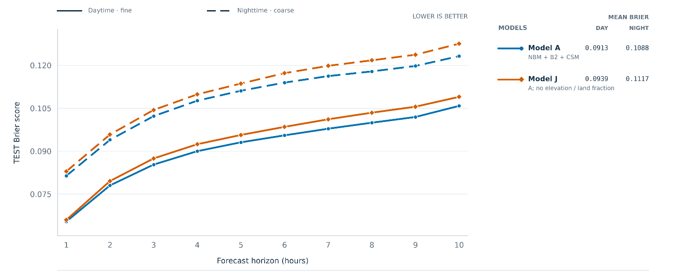
Figure P4-F4. Daytime and nighttime forecast for Model A (reference) and Model J (removal of static land feature inputs [elevation and land fraction]). The dashed and solid lines represent nighttime and daytime forecast performance, respectively.

6. Is additional recent cloud evolution useful?
In reference Model A, only the current satellite image is provided. In Model C, the previous-hour satellite image is also provided, which is meant to test whether providing recent cloud evolution in the form of previous-hour satellite images, would help the model infer cloud movement, growth, and dissipation.

As shown in Figure P4-F5, Model C performed worse than Model A, signifying perhaps that the addition of the previous-hour satellite image doesn’t provide the model with more useful information about the future, than is already contained in the NBM hourly forecast inputs.

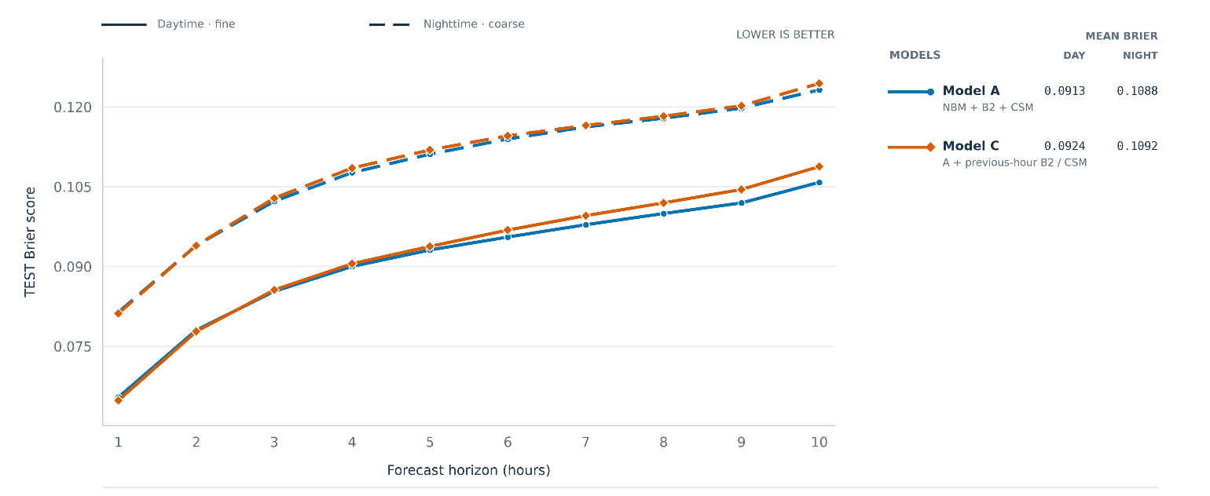
Figure P4-F5. Daytime and nighttime forecast for Model A (reference) and Model C (Model A with the addition of previous-hour satellite image, in addition to the current satellite image). The dashed and solid lines represent nighttime and daytime forecast performance, respectively.

7. Are additional forecasting inputs useful?
Models E and F tested whether adding more granularity to the NBM hourly forecast inputs would help the model make accurate predictions. Model E is almost the same as Model A, with the addition of the NBM forecast input uncertainty, i.e., for each forecast and spatial location, how certain the NBM model is about the cloudiness at that time and location. The hypothesis was that this could provide ensemble disagreement as an uncertainty cue for adjusting the model’s reliance on NBM guidance. Model F is also almost the same as Model A, but with the addition of low-cloud (below 3,000 ft) probability maps and masks, in addition to the total-cloud cover probability maps and masks already provided in Model A. The hypothesis was that providing targeted low-cloud cover predictions that cannot be recovered from total cloud cover alone, could help the model adjust its predictions depending on the height of the cloud cover.

Figure P4-F6 illustrated the the Brier score on the test set for these two ablations. In both cases, given the CI reported in Table P4-T1, improvement over Model A is inconclusive.

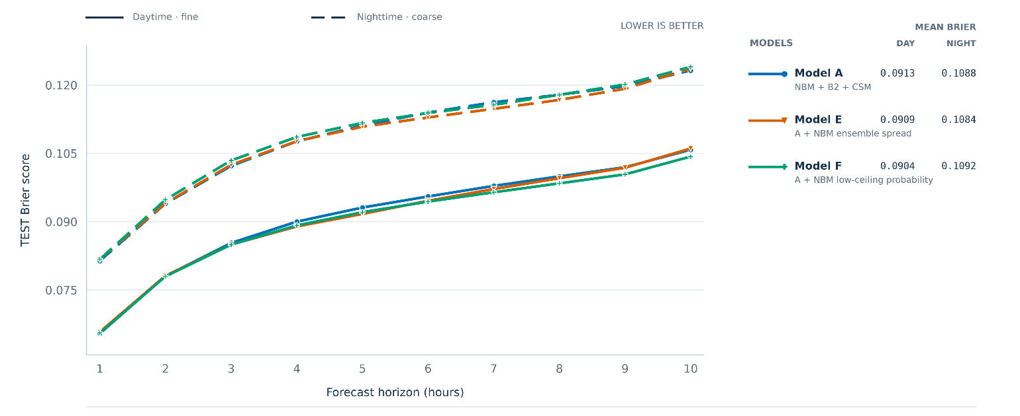
Figure P4-F6. Daytime and nighttime forecast for Model A (reference), Model E (Model A with the addition of NBM forecast uncertainty maps), and Model F (Model A with the addition of NBM low-ceiling cloud probability [in addition to NBM total cloud probability which is provided in Model A]. The dashed and solid lines represent nighttime and daytime forecast performance, respectively.

7. What about blends of different seeds?

It is often reported in the literature that using a blend of models trained with the same architecture but different seeds, can perform better than any single seed individually. Figure P4-F7 shows a three-seed blend for Model I (which includes the single-seed model), and it can be seen that it performs better than the single-seed Model I across the board. Based on the CI reported in Table P4-T1, the improvement is also concluded to be significant. This
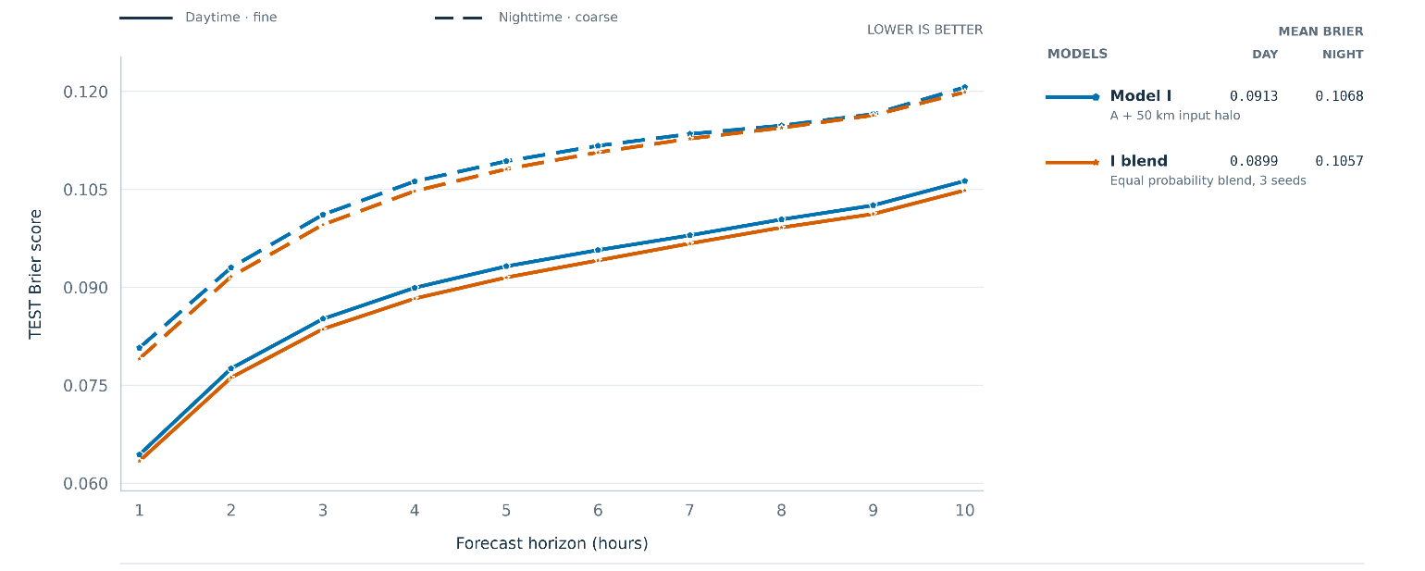
Figure P4-F7. Daytime and nighttime forecast for single-seed and three-seed-average Model I blend. The dashed and solid lines represent nighttime and daytime forecast performance, respectively.

Ablation without solar incidence angle?
Add variations of training recipes? Different learning schedules, etc.

But how good is it really?
We’ve looked at a total of 10 different model ablations. We’ve selected Model I three-seed blend. Now, the most important question remaining is: how good is it compared with selected baselining forecasting references? This is the focus of the next post.
POST 5

Does Fogcast forecast better, or just draw maps with a finer discretization?

A fair comparison
Table P5-T1 describes the three forecast references that were used to benchmark the neural networks trained. Persistence is a standard and utmost-simple reference for forecasting models, as it assumes that the current state will persist for all future times.

Table P5-T1. Description of the three forecast references used for baselining against the neural network results.
Baseline | Forecast construction | Information used | Mean TEST Brier score
Baseline | Forecast construction | Information used | Daytime fine grid | Nighttime coarse grid
Persistence  Current-state forecast | Hold the current continuous B2 clear score fixed at every lead. Where B2 is unavailable, use current CSM, then neutral 0.5 if both are unavailable. | Issue-time B2 + CSM;  no future observations | 0.2183 | 0.2084
Climatology  Historical frequency | Use the TRAIN-only clear frequency at each location, indexed by target month and Pacific local hour, with prior smoothing. | Historical TRAIN labels;  target calendar month + hour | 0.2046 | 0.2103
NBM Predictions  Using forecast labels directly | Convert NBM total sky cover C (%) to a clear score: 1 − C/100. Align the target-hour field to the verification grid | NBM forecast available at issue time;  typical lag of 2 hours (i.e., +1 hour forecast uses NBM predictions from 3 hours ago) | 0.1156 | 0.1331

Figure P5-F1 illustrates for a sample time, the base neural network model (Model A) and reference forecasts, as well as corresponding training labels. All fields are thresholded for ease of visualization, but in practice all shown fields except for persistence, are continuous fields from 0 to 1.
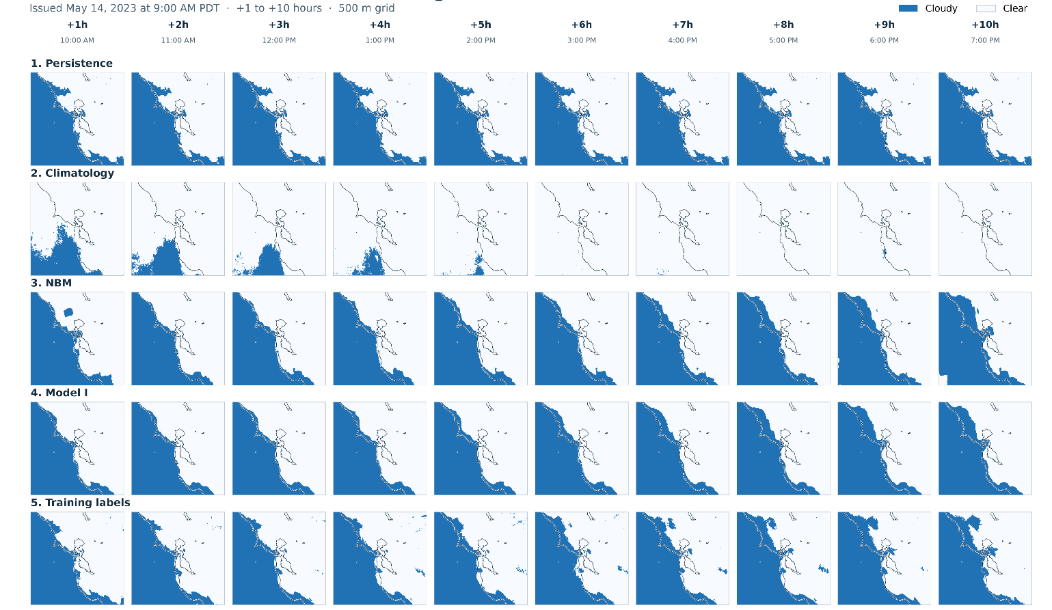
Figure P5-F1. Sample Model A and reference forecasts, as well as corresponding training labels, all thresholded for ease of visualization. Data timestamp: 2023-05-14 at 9:00AM PDT.

Figure P5-F2 compares the base model (Model A) with three reference forecasts: persistence, climatology, and direct predictions from NOAA’s National Blend of Models (NBM), which provides total cloud cover forecasts on a coarser grid. Among the reference forecasts, persistence achieves the lowest Brier score at the +1-hour horizon, but its performance deteriorates as lead time increases. Climatology remains nearly constant across forecast horizons, while direct NBM achieves the lowest mean Brier score across the ten horizons.

Persistence’s advantage over NBM at +1 hour may partly reflect the difference in information age. This evaluation uses NBM cycles initialized two hours before each forecast issue time to account for availability delays. Consequently, the NBM prediction for one hour ahead is a three-hour forecast from that earlier cycle. Persistence instead carries forward the latest available satellite-derived state. Access to more recent observations may therefore contribute to its stronger performance at the shortest lead time.

Model A achieves lower Brier scores than all three reference forecasts at every evaluated horizon. Its advantage over NBM, the strongest reference overall, is greatest at short lead times and narrows as the forecast horizon increases. This pattern is consistent with the benefit of incorporating recent, high-resolution satellite-derived clear-sky information: current observations provide valuable detail for near-term forecasts, but become less informative about future conditions as lead time increases. The NBM forecasts supplied to Model A may therefore play a larger role at longer horizons.

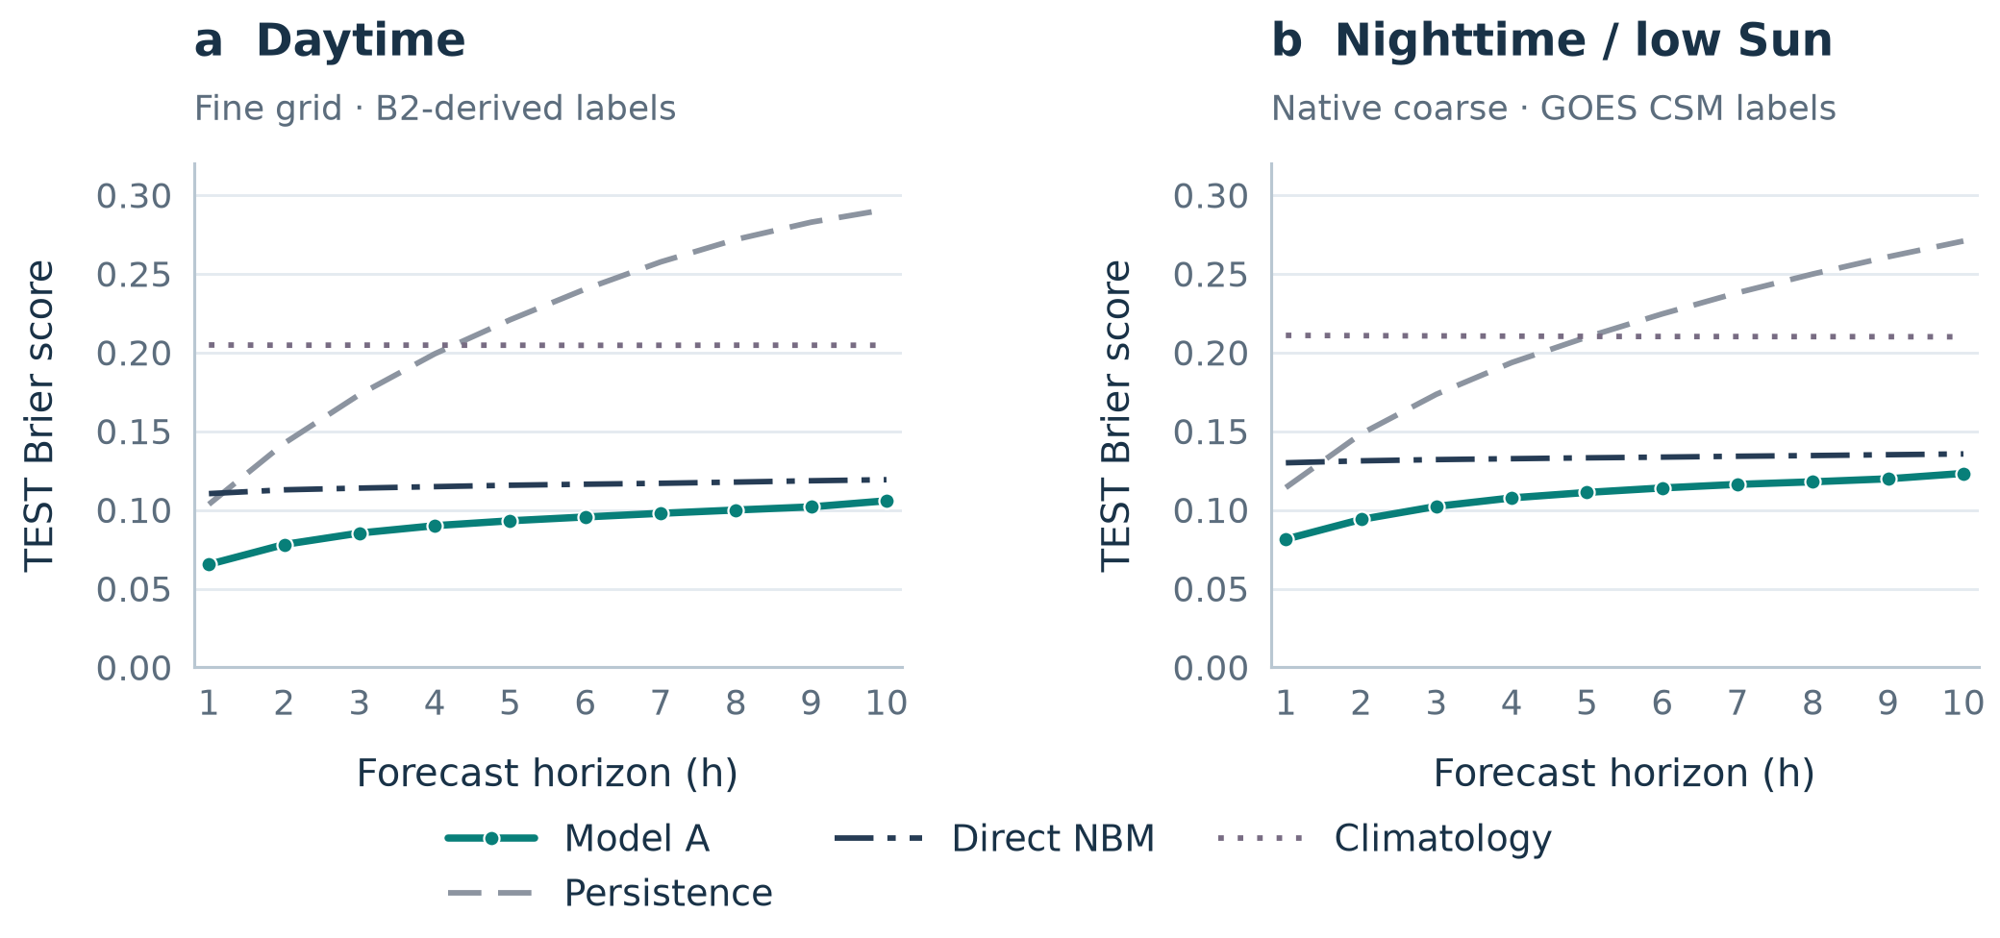
Figure P5-F2. Forecast performance of Model A compared with three reference forecasts: persistence, climatology, and direct NBM.

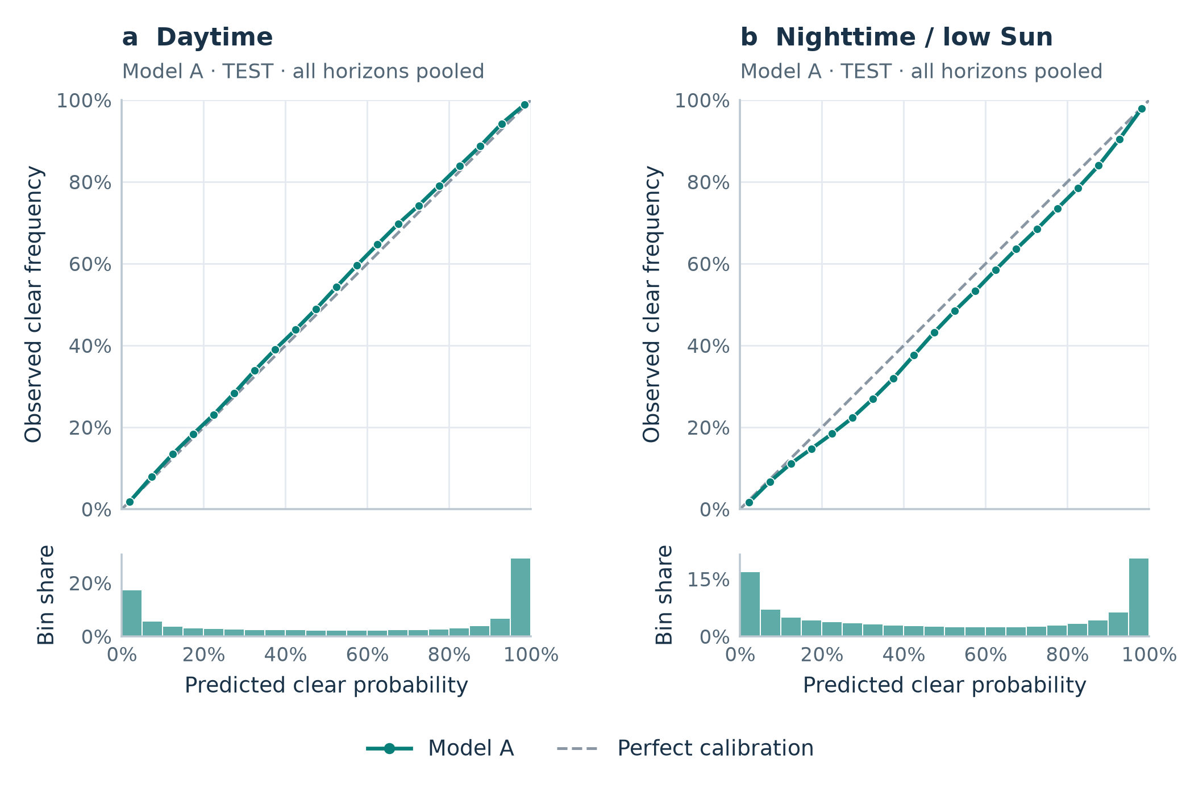
Figure P5-F3. Reliability plot for Model A, combining all 10 forecast horizons and using 5% bins.

5. The honest assessment

Some of the model variations (Models B, D, J, K) were ablations meant to verify the usefulness of having certain inputs feed the model. They all conclusively performed worse than the reference Model A, and thus showcased the usefulness of incorporating each of the Model A inputs.

Other model variations (Models C, E, F, G, I) were attempts at improving the “fogcasting” accuracy. However, all but one (Model I; expanded 300x300 km2 input domain) of these improvement attempts failed to show conclusively an improvement over the reference model.

Therefore, the final retained model, the blend of 3 seeds of Model I, is very similar to the Model A, and performs conclusively better, however only slightly better. The good news is that the retained model significantly outperforms all 3 selected baselines (persistence, climatology, and NBM total cloud cover predations), at all forecasting horizons. It is thus, as far as I’m concerned, the tool I will use to plan my next picnic in San Francisco, in assessing whether Ocean Beach will likely clear up before sunset, or whether I should move it to Dolores Park.

